



SETUP DOCUMENT

LARP EVENT SOFTWARE SOLUTION

Version 2.0

Dholon Akter | Nr. 3047040

Chanelle Hart | Nr. 3323781

Talia Santos | Nr. 3294579

Thanh Hoàng | Nr. 3353362

GROUP 34

# Version History

|  |  |  |  |  |  |
| --- | --- | --- | --- | --- | --- |
| **Version #** | **Implemented By** | **Revision Date** | **Approved By** | **Approval Date** | **Reason** |
| 0.5 | T. Santos | 6th Mar | - | - | Rough draft |
| 0.6 | C. Hart | 9th Mar | - | - |  |
| 1.0 | T. Hoàng | 11th Mar | - | - | Add GUIs, Wireframes, ERD |
| 2.0 | T. Hoàng | 18th Mar | - | - | Finalization |
| 3.0 | T. Santos | 24th Jun | - | - | Touch up, remove old GUI for replacement |

Table of Contents

Version History 2

Agreements 8

Functional Requirements 8

GUI 9

Login forms for all applications 9

Entrance application 9

Manager application 12

Rental Application 15

Entrance application 17

Wireframes 18

Homepage: 18

Story So Far page: 19

Rules page: 20

Events page 21

Activities page: 22

Food, drinks and loaning items page 23

Games page: 24

Camping page: 25

News page: 26

News – read more: 27

About page: 28

Login page: 29

Sign up page: 30

Participant’s information page 31

Participant’s information page 32

Camping registration page: 33

Bundles page: 34

Visual Design 35

Homepage: 35

Story So Far: 36

Rules page: 37

Events page 38

Activities page: 39

Food, drinks and loaning items page 40

Games page: 41

Camping page: 42

News page: 43

News – read more: 44

About page: 45

Login page: 46

Sign up page: 47

Participant’s information page 48

Participant’s information page 49

Camping registration page: 50

Bundles page: 51

ERD 52

# Agreements

**Applications:**

* The applications should have functionalities supporting the management and personnel of the events.
* The applications will run on Windows.
* The applications should be user-friendly and accessible to all personnel and management.
* The applications for stores and loan stands should be self-service.

**Website:**

* The website should have functionalities supporting the purchase tickets and/or reservations of camping spots.
* The website should be visually appealing and informative to potential visitors.
* All personal information on the website will be carefully stored.
* The website will be able to run on mobile devices.

# Functional Requirements

*Table 1. Functional requirements classified.*

|  |  |  |  |  |
| --- | --- | --- | --- | --- |
|  | **Must have** | **Should have** | **Could have** | **Won’t have** |
| **Website** | [WMH1] Website is informative  [WMH2] Website has visual appeal  [WMH3] User can purchase tickets  [WMH4] User can reserve camps  [WMH5] Website stores information safely | [WSH1] Website is responsive on mobile devices | [WCH1] Website can have an about page for the company  [WCH2] Website can have an about page for the events  [WCH3] Website can have room for feedback  [WCH4] Website can have links to social media  [WCH5] Website can have a picture gallery | [WWH1] Website will not process payments |
| **Applications** | [AMH1] Application can monitor visitors: enter, exit and quantity  [AMH2] Application supports selling and loaning items  [AMH3] User can have an overview of the event  [AMH4] Application can handle ATM logs  [AMH5]  Application can run on Windows | [ASH1] Application is user-friendly  [ASH2] Application have manuals | [ACH1] A mobile application for stores and loan stands |  |

# GUI

## Login forms for all applications

All applications require authentication before the user can access the functionalities. Below is how said form would look.

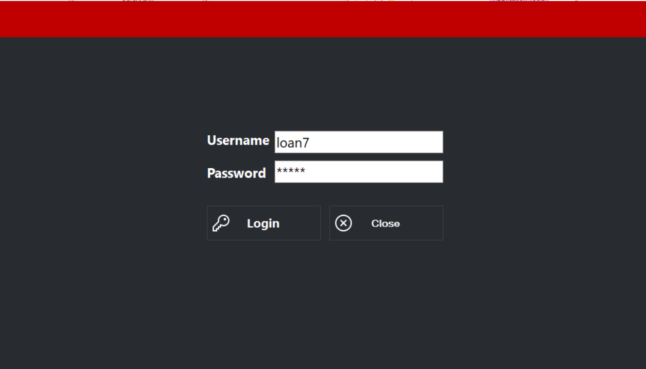

Figure . Login form for all applications

## Entrance application

The entrance application has two sections:

1. Check-in: The section used for scanning and checking in visitors (see Figure 2.1)
2. Logs: The section used to see and/or search relevant data (see Figure 2.2)

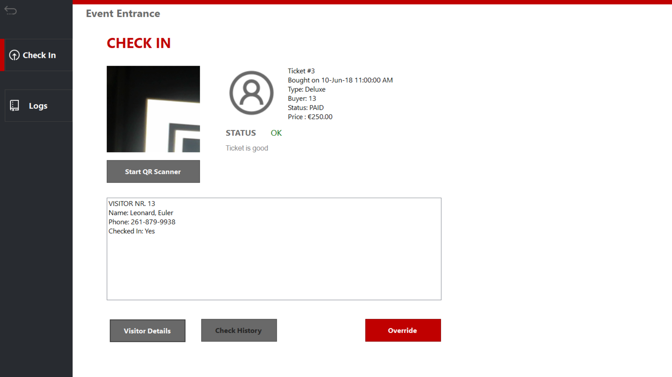

Figure .1 Check-in form for the event

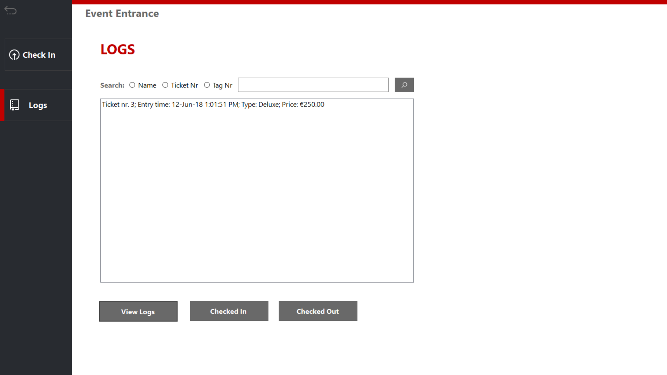

Figure 2.2 Ticket logs for event application

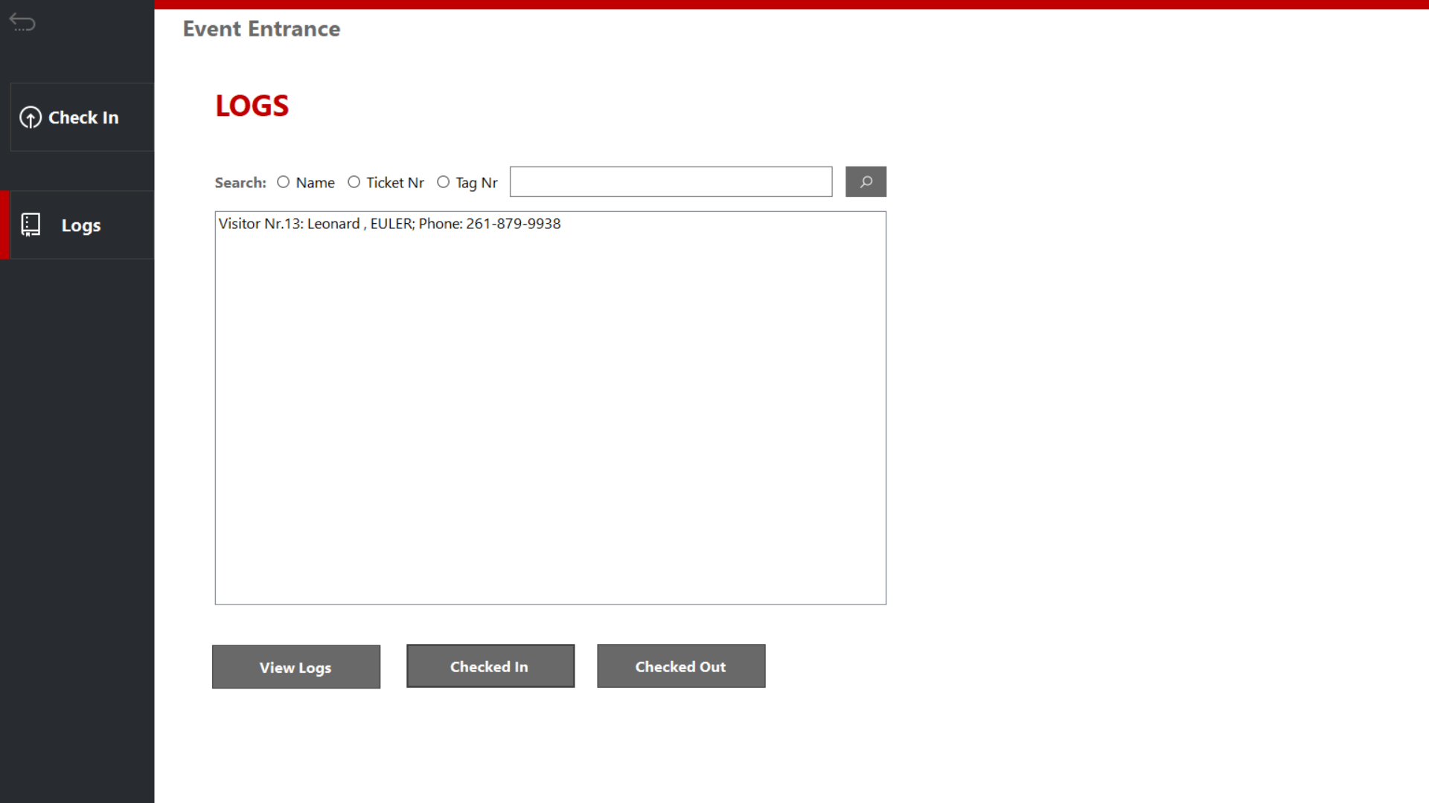

Figure 2.3 Visitor logs for entrance application

## Manager application

Manager has a home section where you can go into several sections, as can be see from the buttons in Figure 3.

1. Visitors: where you can check a variety of data related to people visiting the event (see Figure 3.1)
2. Staff: personnel related data (see Figure 3.2)
3. Camping: campsite related data (see Figure 3.3)
4. Transactions: ATM related logs and data (see Figure 3.4)
5. Logout brings you back to the login form.

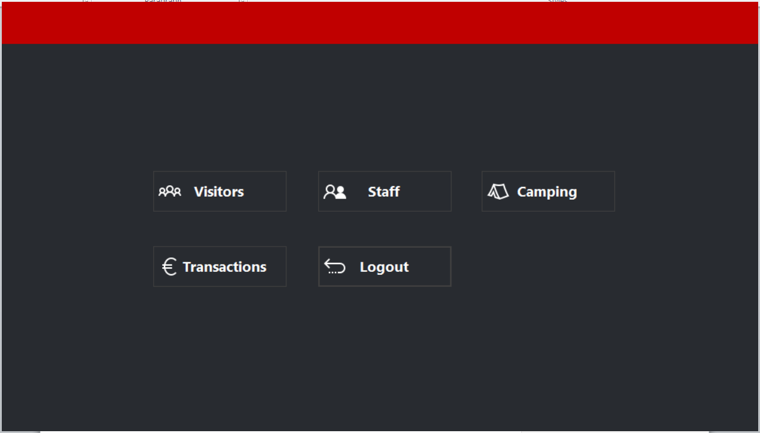

Figure . Home form

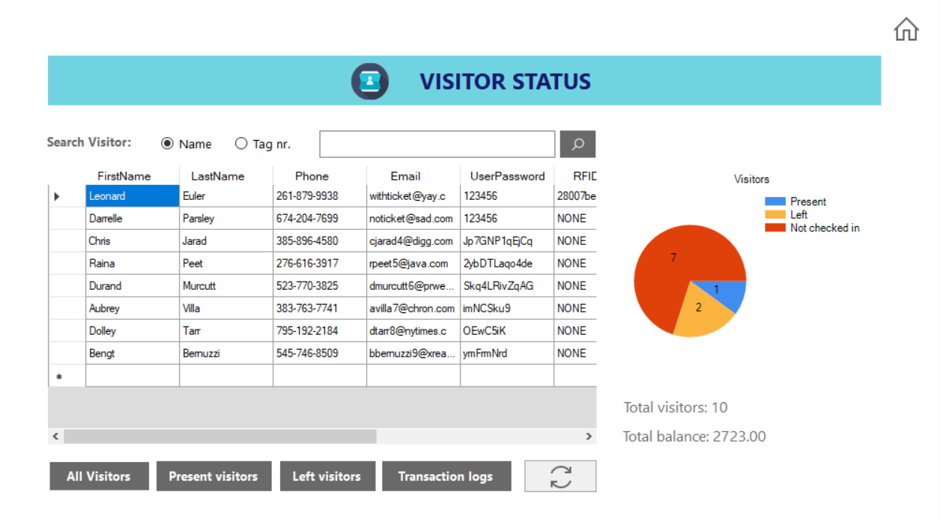

Figure 3.1 Visitor data

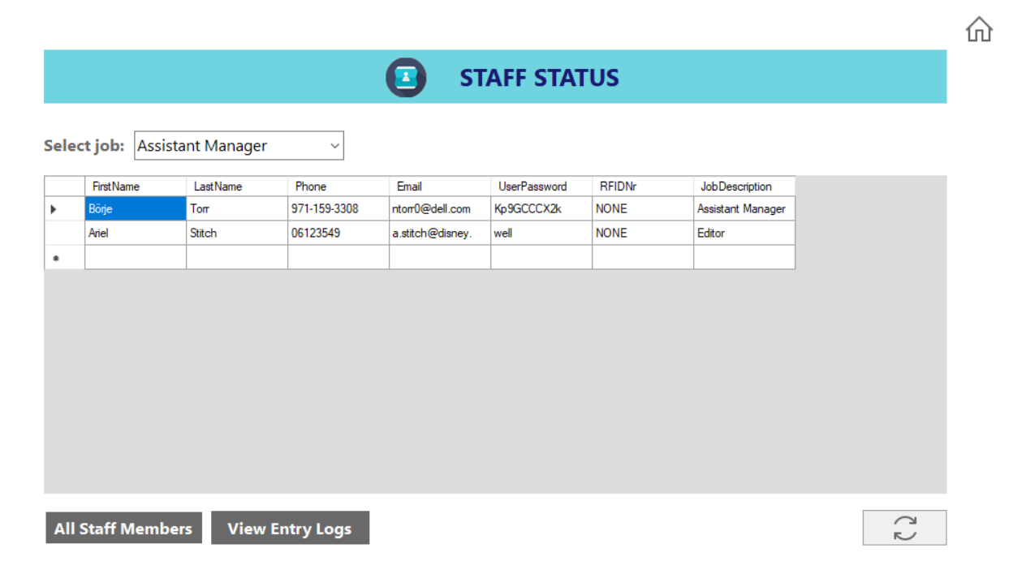

Figure 3.2 Staff data

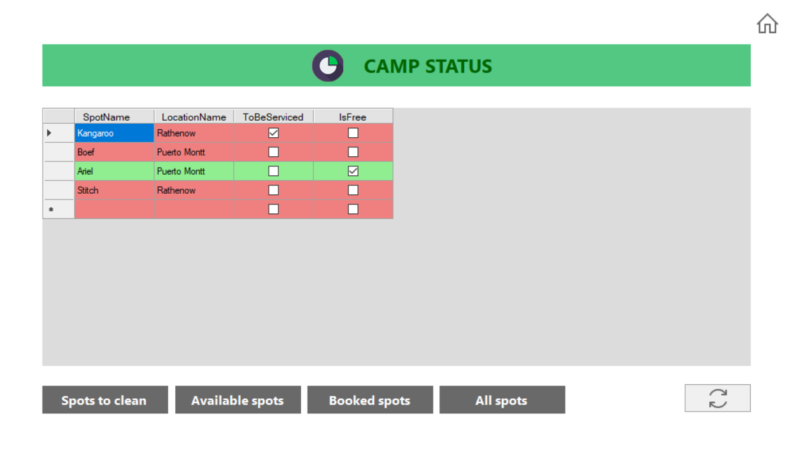

Figure 3.3 Camp data

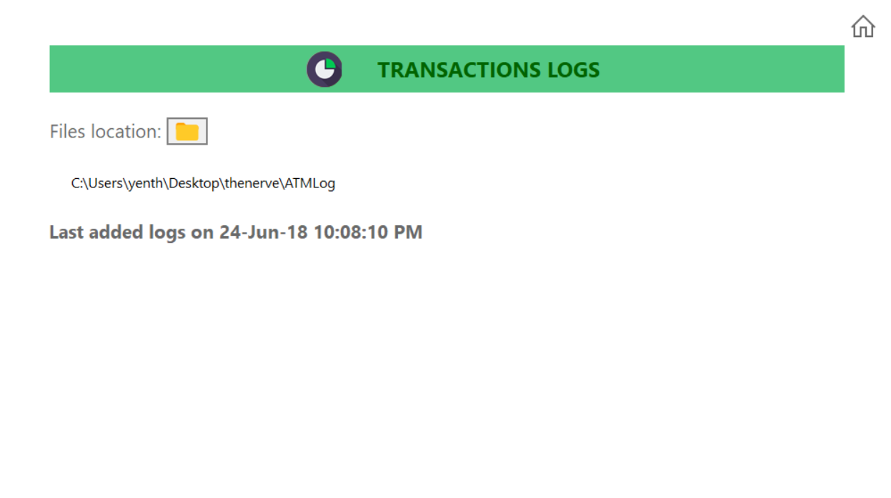

Figure 3.4 Transactions logs

## Rental Application

The rental application has three sections:

1. Loaning: The section used for scanning items that visitors might want to borrow (see Figure 4.1)
2. Returning: Section used for scanning items that visitors are returning (see Figure 4.2)
3. Logs: The section used to see and/or search relevant data (see Figure 4.2)

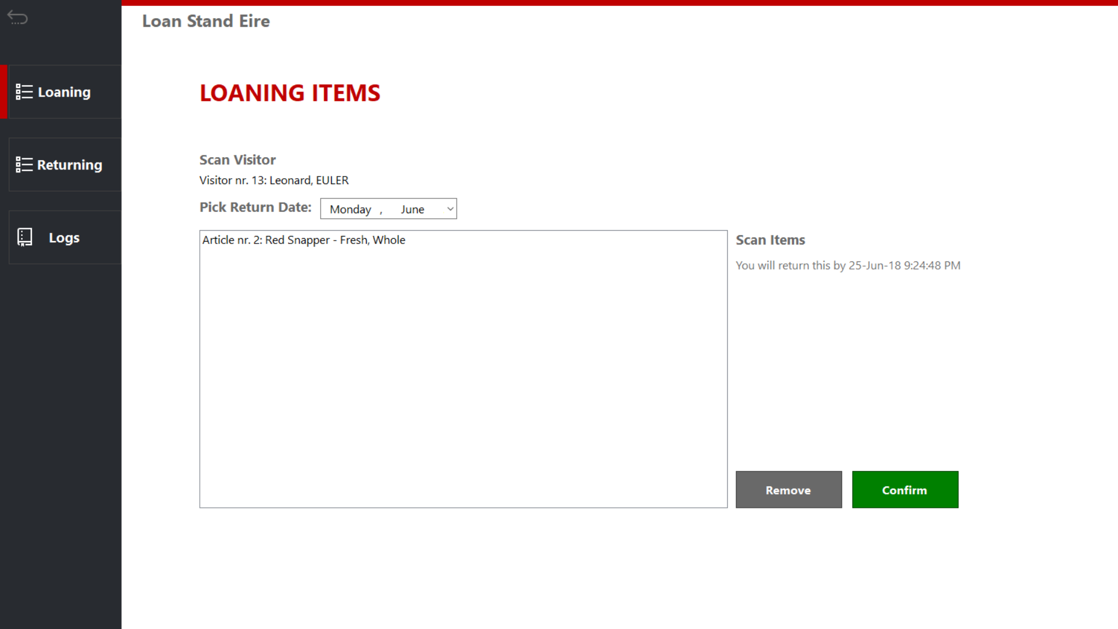

Figure .1 Loan section

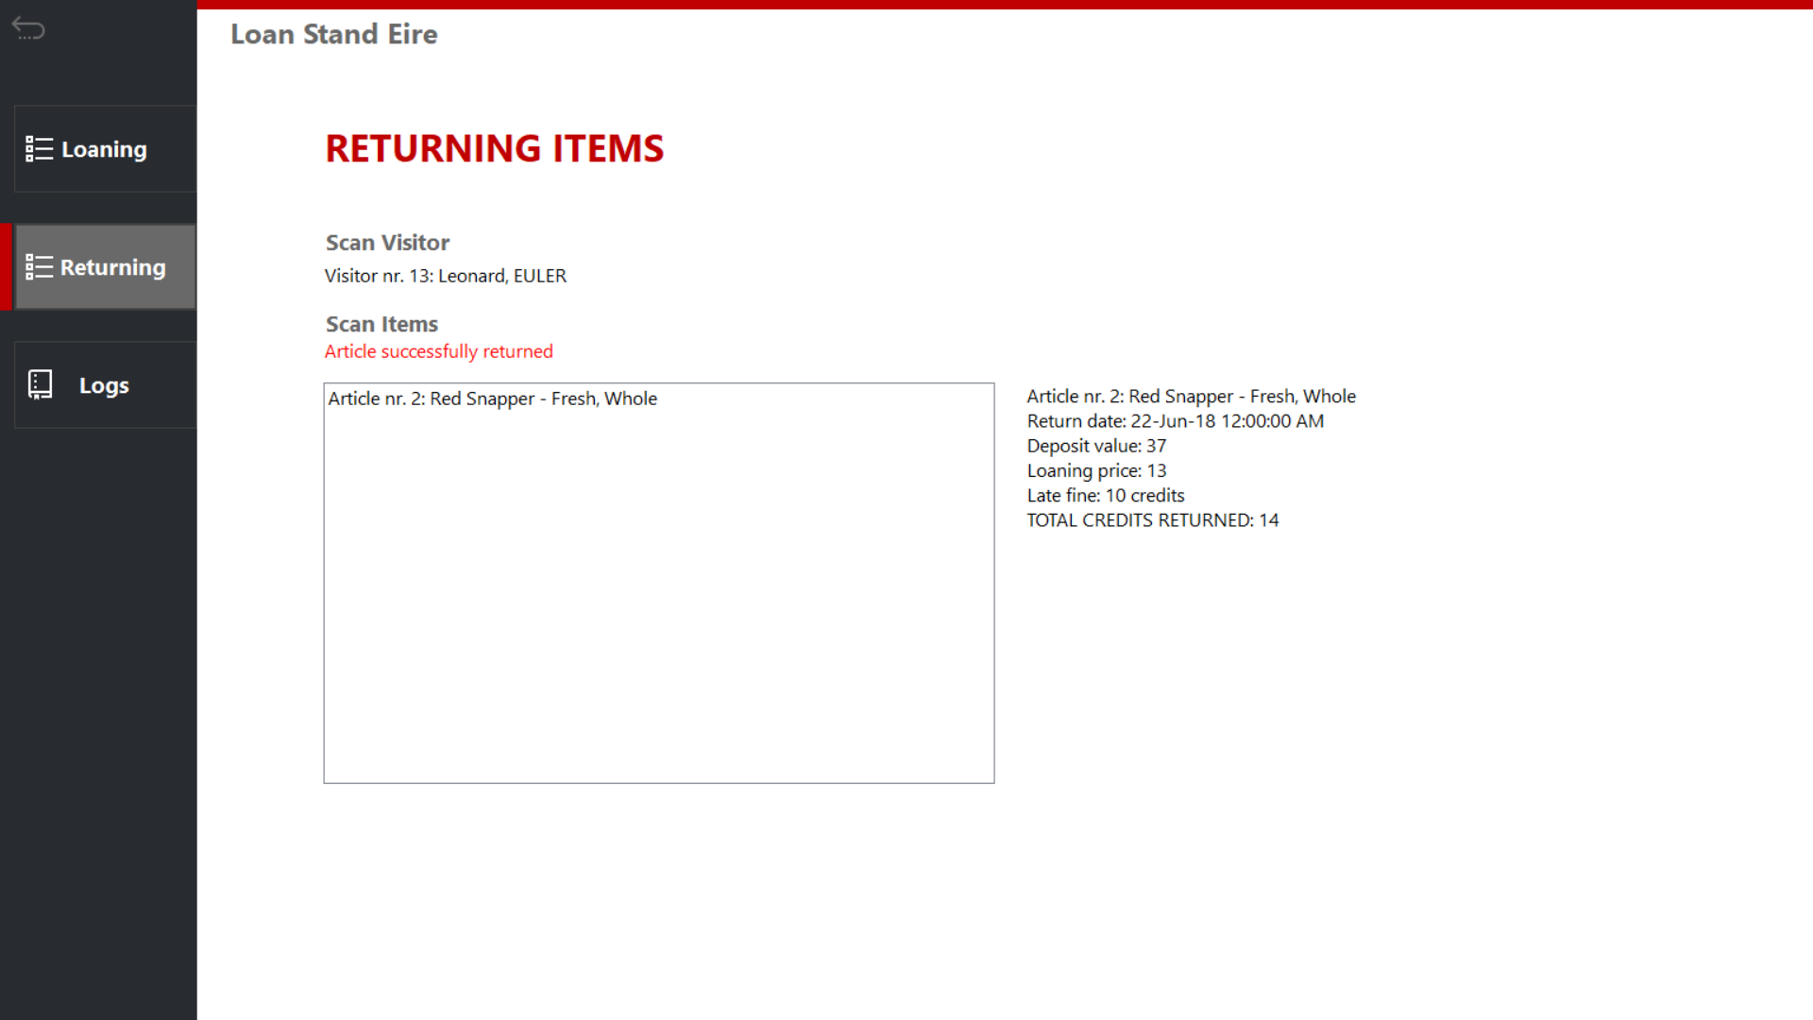

Figure 4.2 Returning items

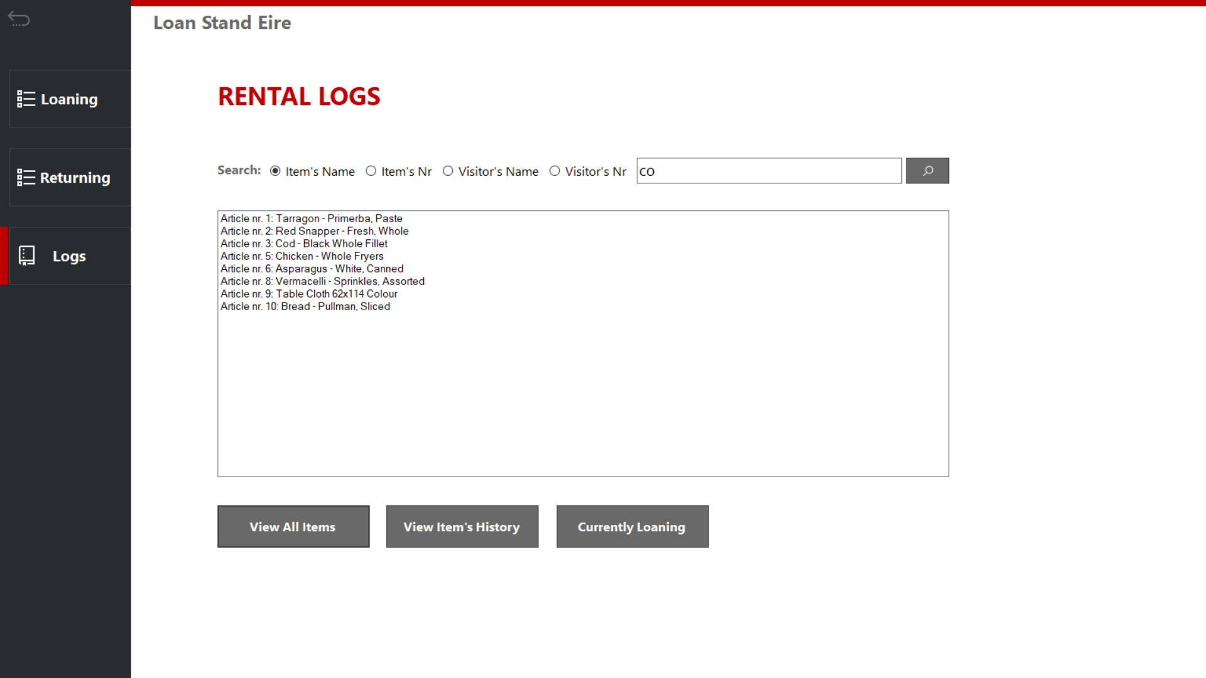

Figure 4.3 Rental logs

## Entrance application

The Store application has two sections:

1. Order: The section used for ordering food or drink items (see Figure 5.1)
2. Logs: The section used to see and/or search relevant data, like stock (see Figure 5.2)

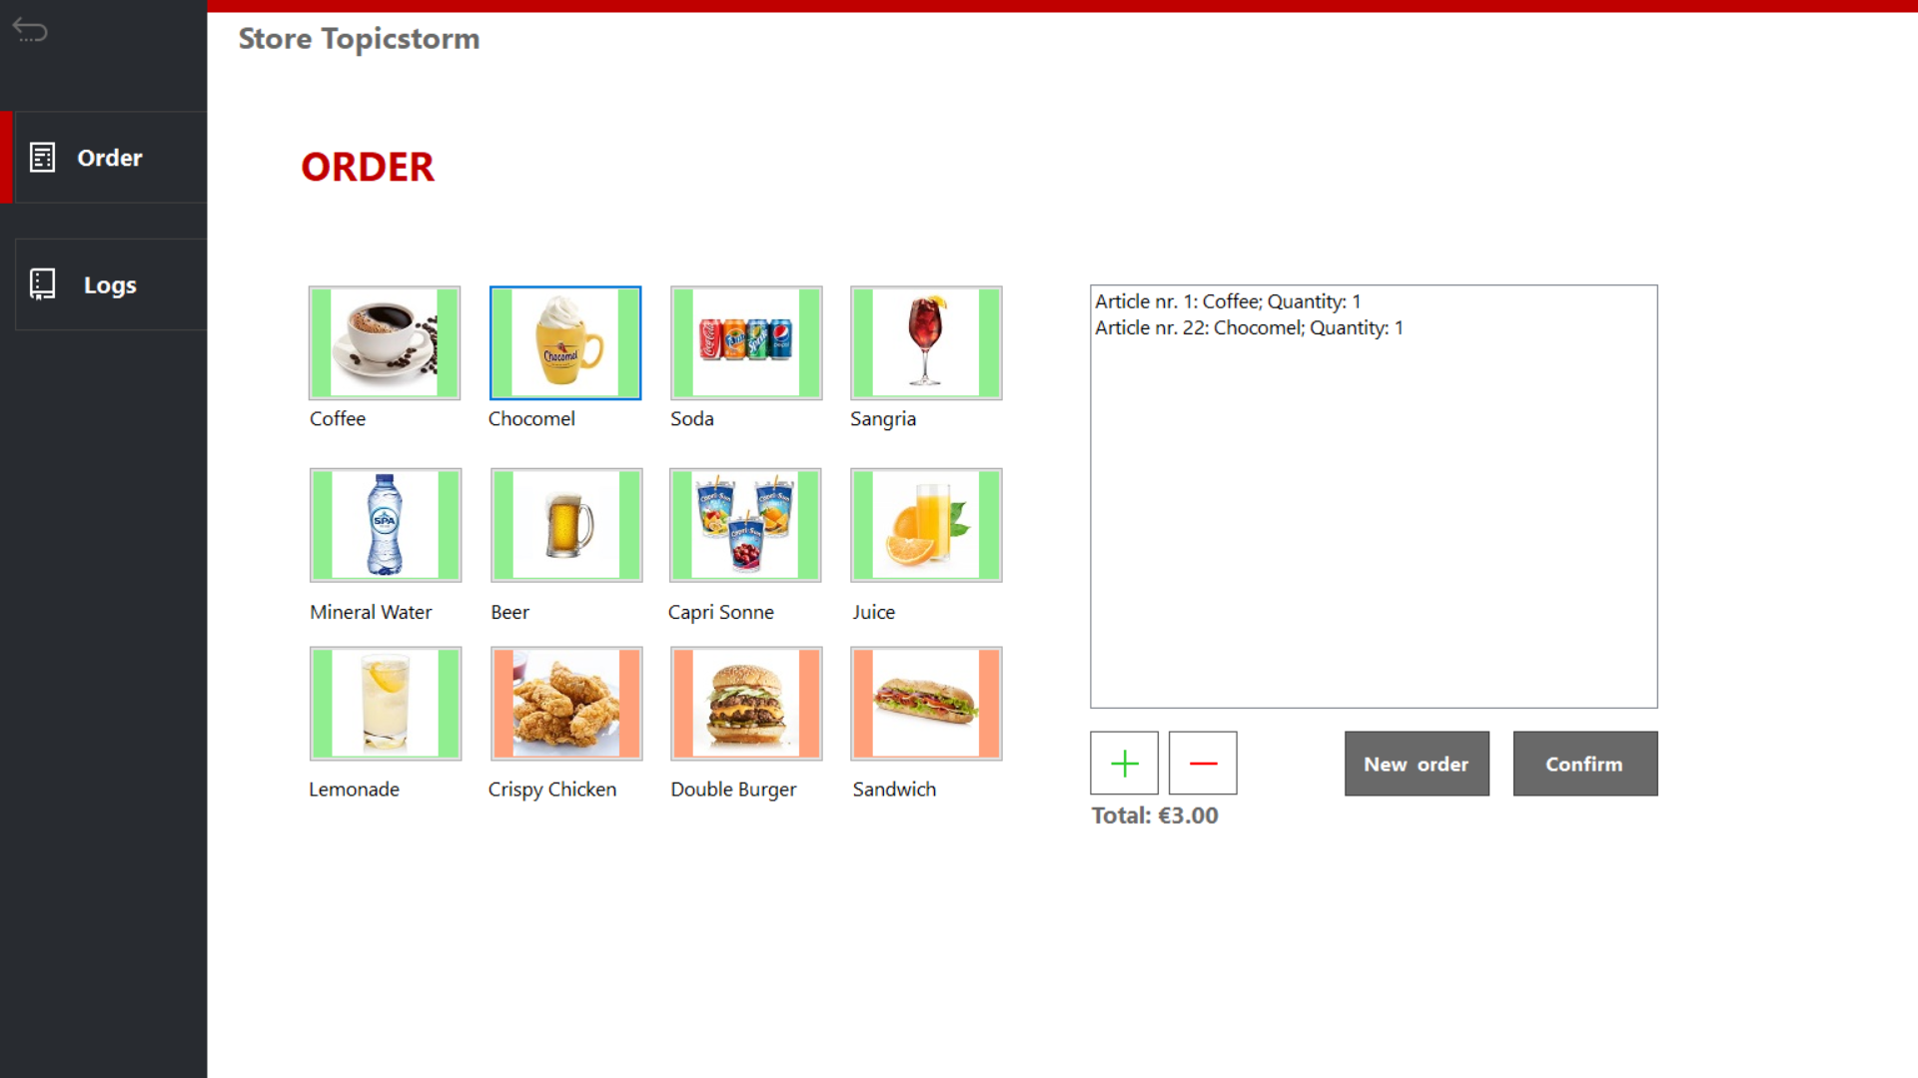

Figure .1 Taking an order

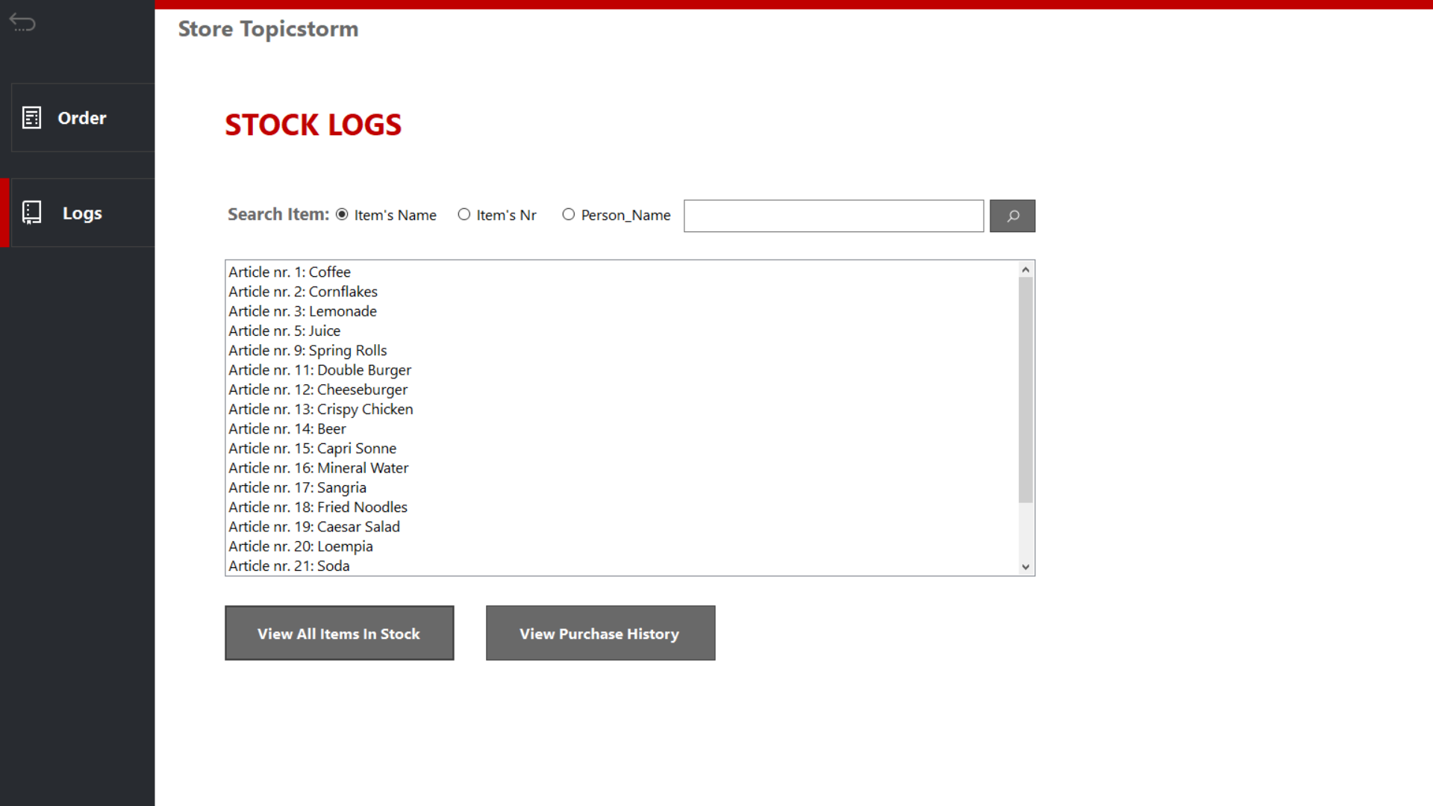

Figure 5.2 Stock logs

# Classes Diagram

The classes are designed to resemble entities in the database, with tweaking to facilitiate storing and retrieving information. They can be thought of as intermediate objects to help with user – database interaction.

When data is retrieved from the database, it will be stored as object of one of the following classes. The objects allow for easier manipulation of data as well as better organization.

This section will present the classes in relation to one another, together with a justification for their design.

## Participants

## C:\Users\yenth\AppData\Local\Microsoft\Windows\INetCache\Content.Word\participantuml.jpg

*Figure 6.1 Participant class and its children*

There are two types of participants at the event: staff and visitors. Both types share the same common information and can be checked in/out of the event – hence, the superclass Participant.

The children class Staff and Visitor holds attributes and methods which are unique to the specified type.

## Ticket

Each visitor coming to the event has a ticket, whose information is stored in the Ticket object.

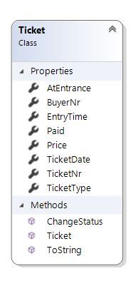

*Figure 6.2 Ticket class*

## Shop

The stores and loan stands are classified as shops and share the same information as follows:

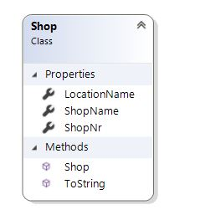

*Figure 6.3 Shop class*

## Articles

Within shops, there are articles. Depending on the shop’s type (a store or a loan stand), the article’s type differs.

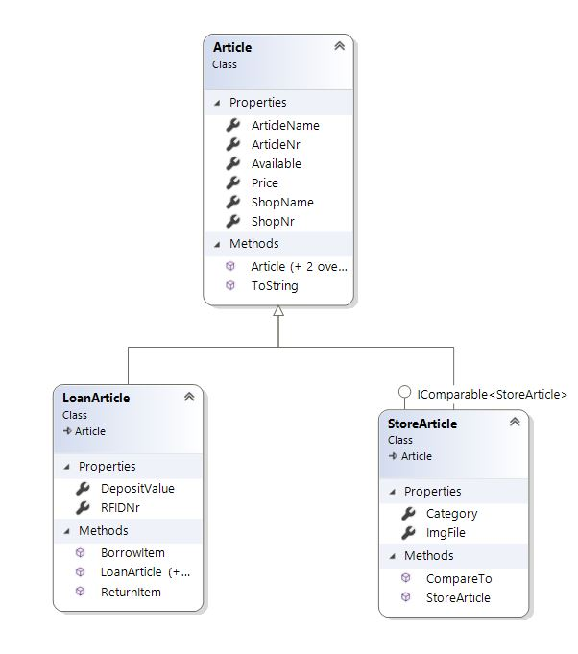

*Figure 6.4 Article class and its children*

All articles share the same basic information which is stored in the Article superclass. Its children holds the unique attributes and method of their type.

## Camping

The camping spots at the event as well as their reservations will have their information stored in the following classes:

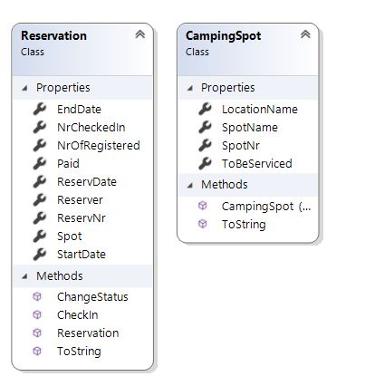

*Figure 6.5 Reservation and CampingSpot classes*

## ATM Logs

It is also required of the applications to be able to transfer logs exported by the bank into the database. To facilitate such process, this class is created.

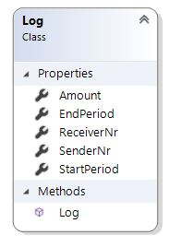

*Figure 6.6 Log class*

# Sitemap and Navigation

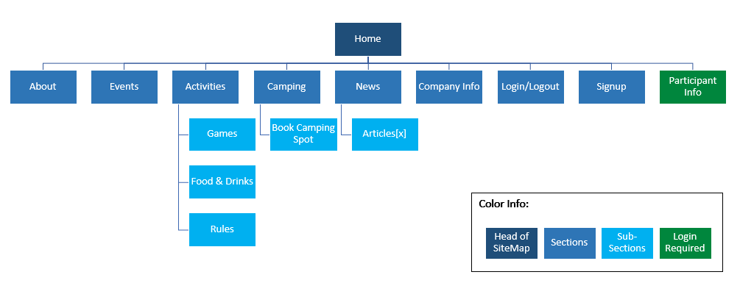

*Figure 7. Sitemap*

# Wireframes

## Homepage:

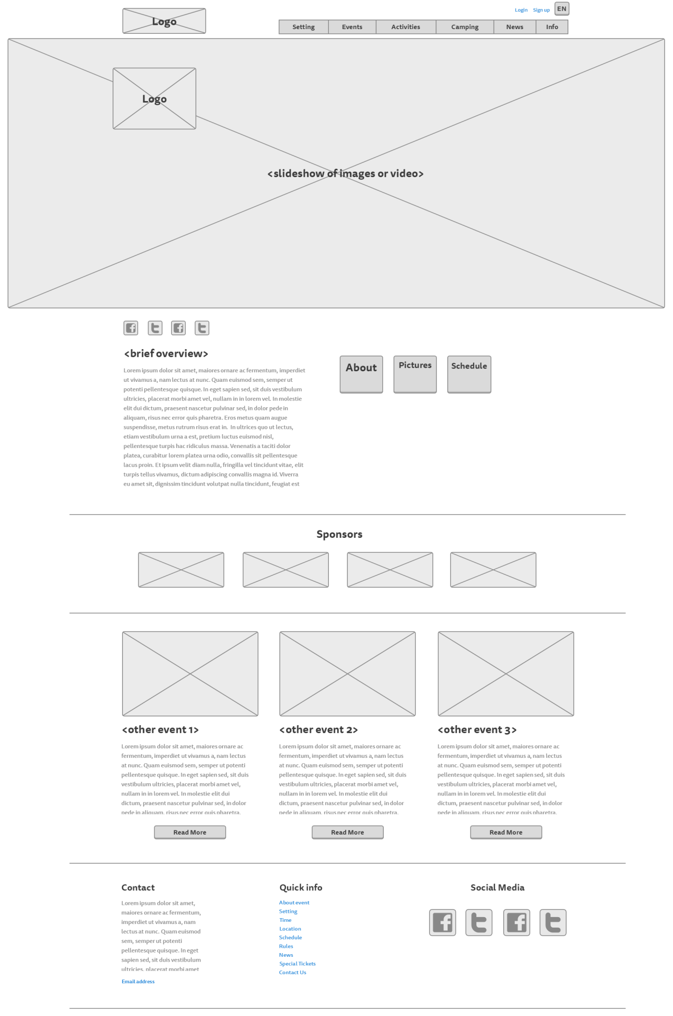

## Story So Far page:

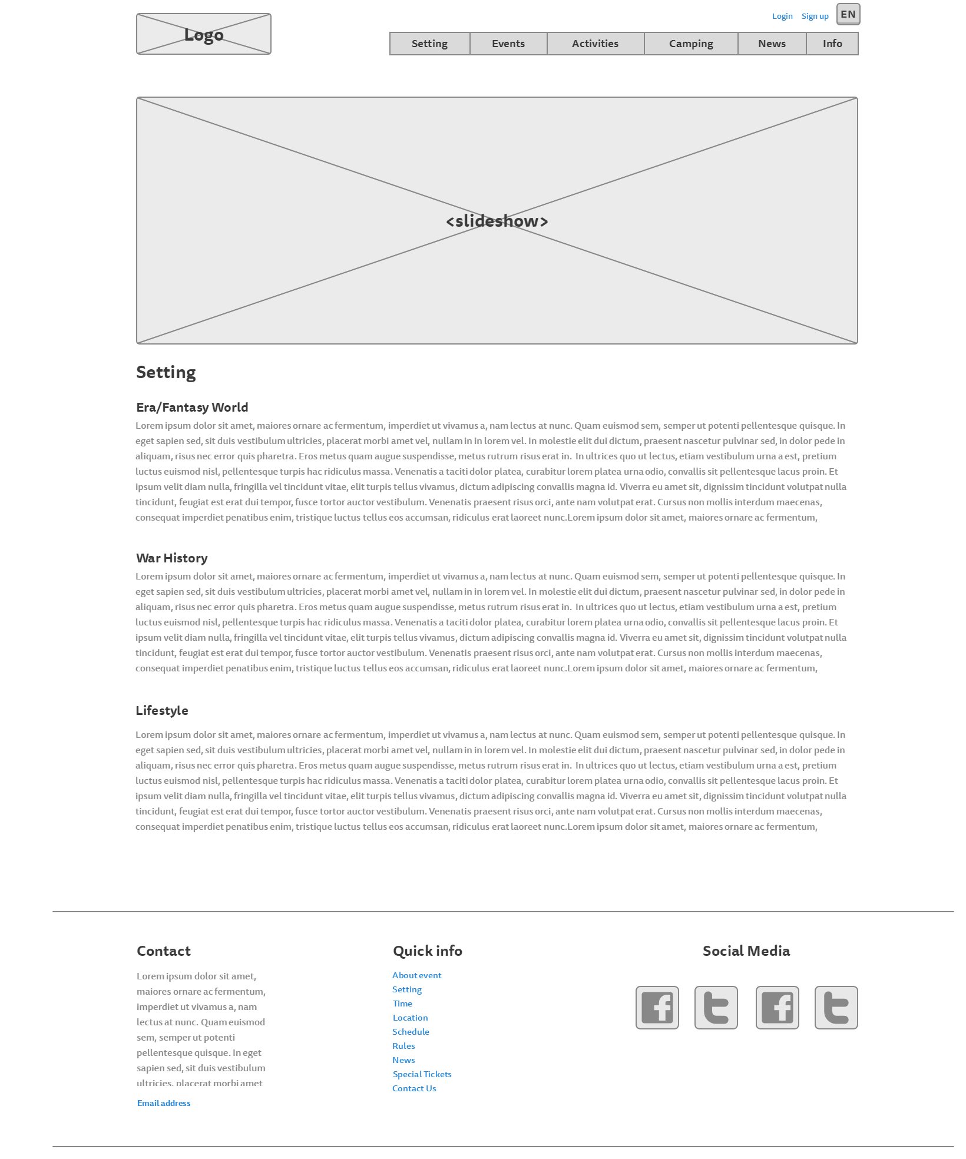

## Rules page:

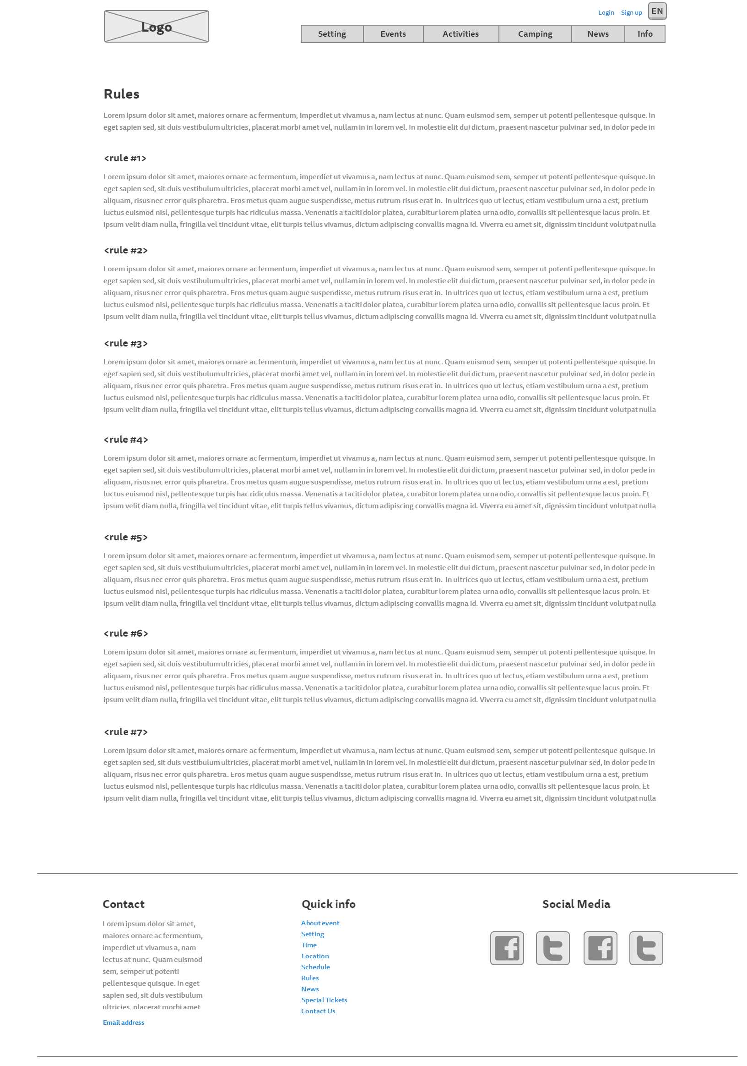

## Events page

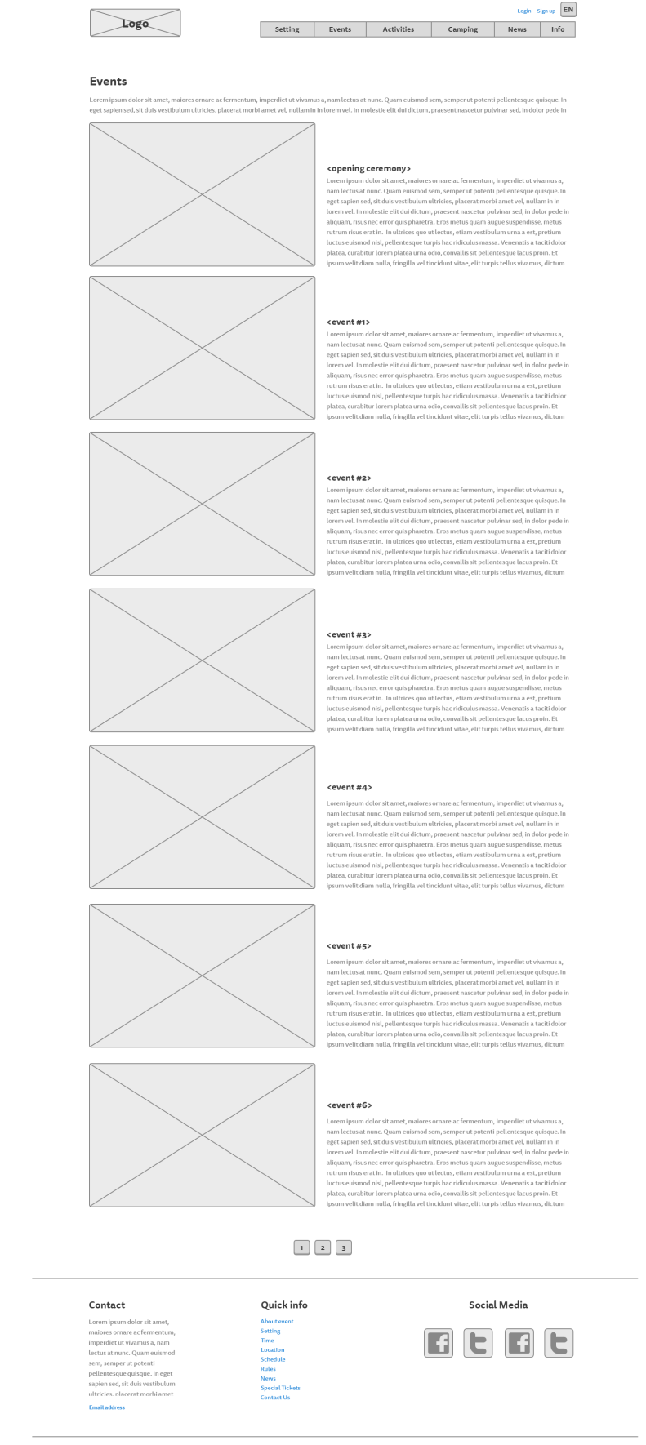

## Activities page:

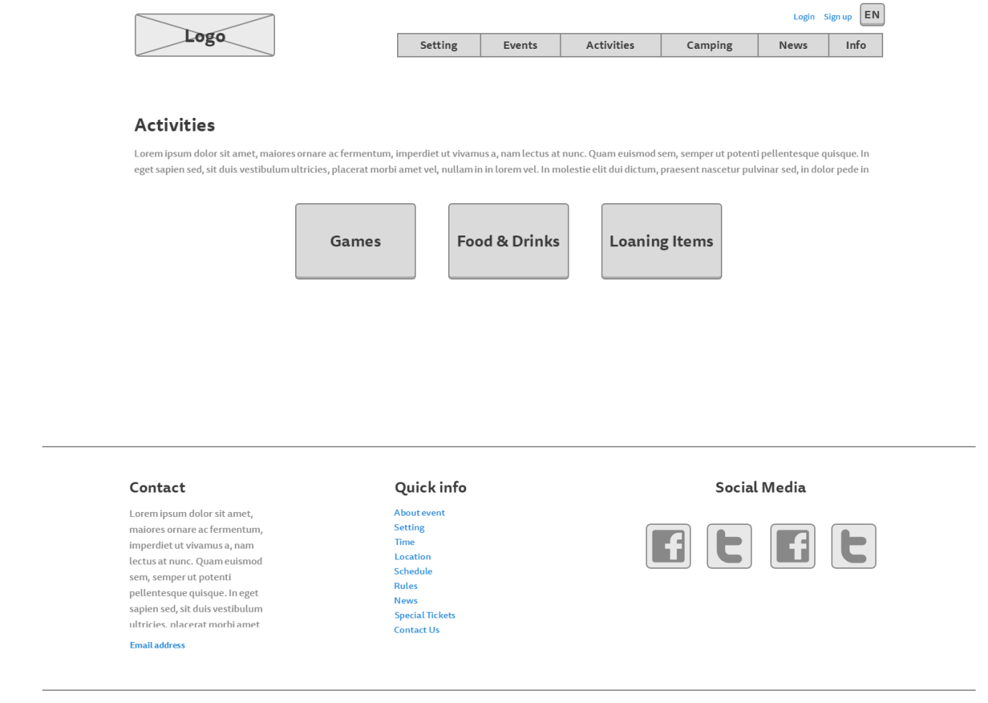

## Food, drinks and loaning items page

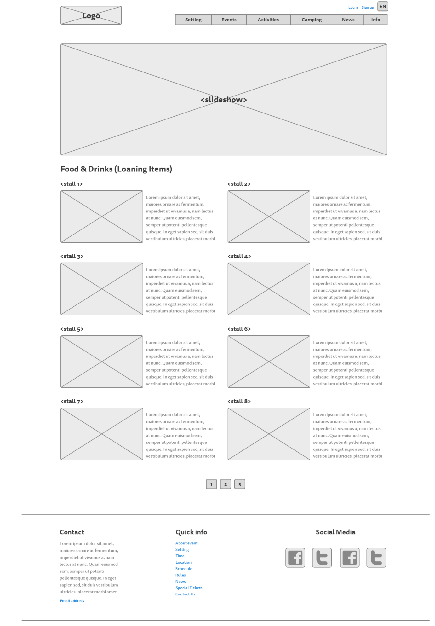

## Games page:

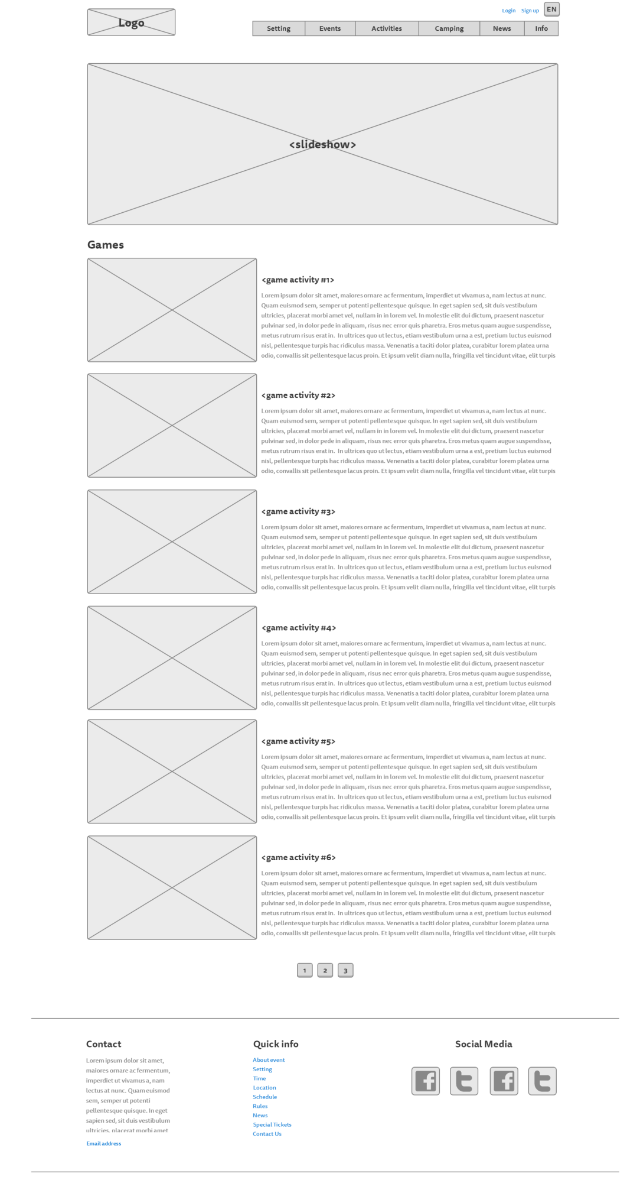

## Camping page:

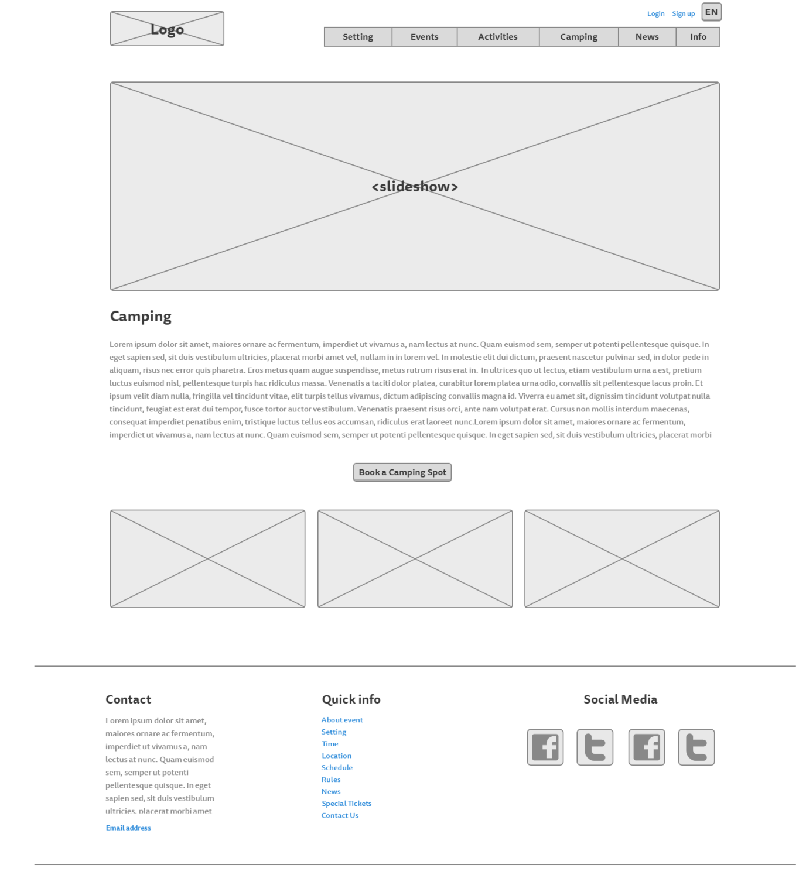

## News page:

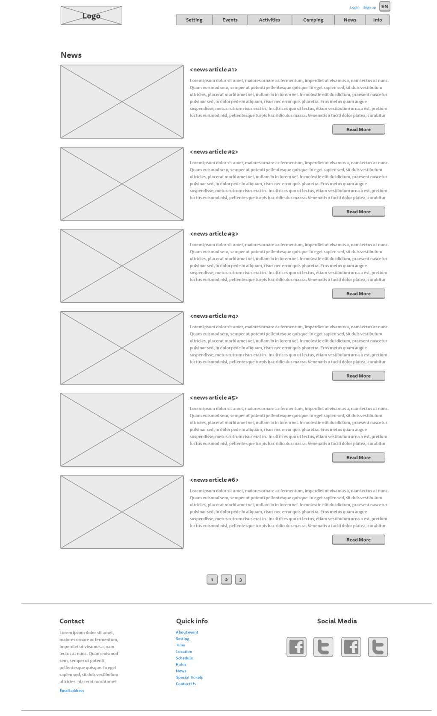

## News – read more:

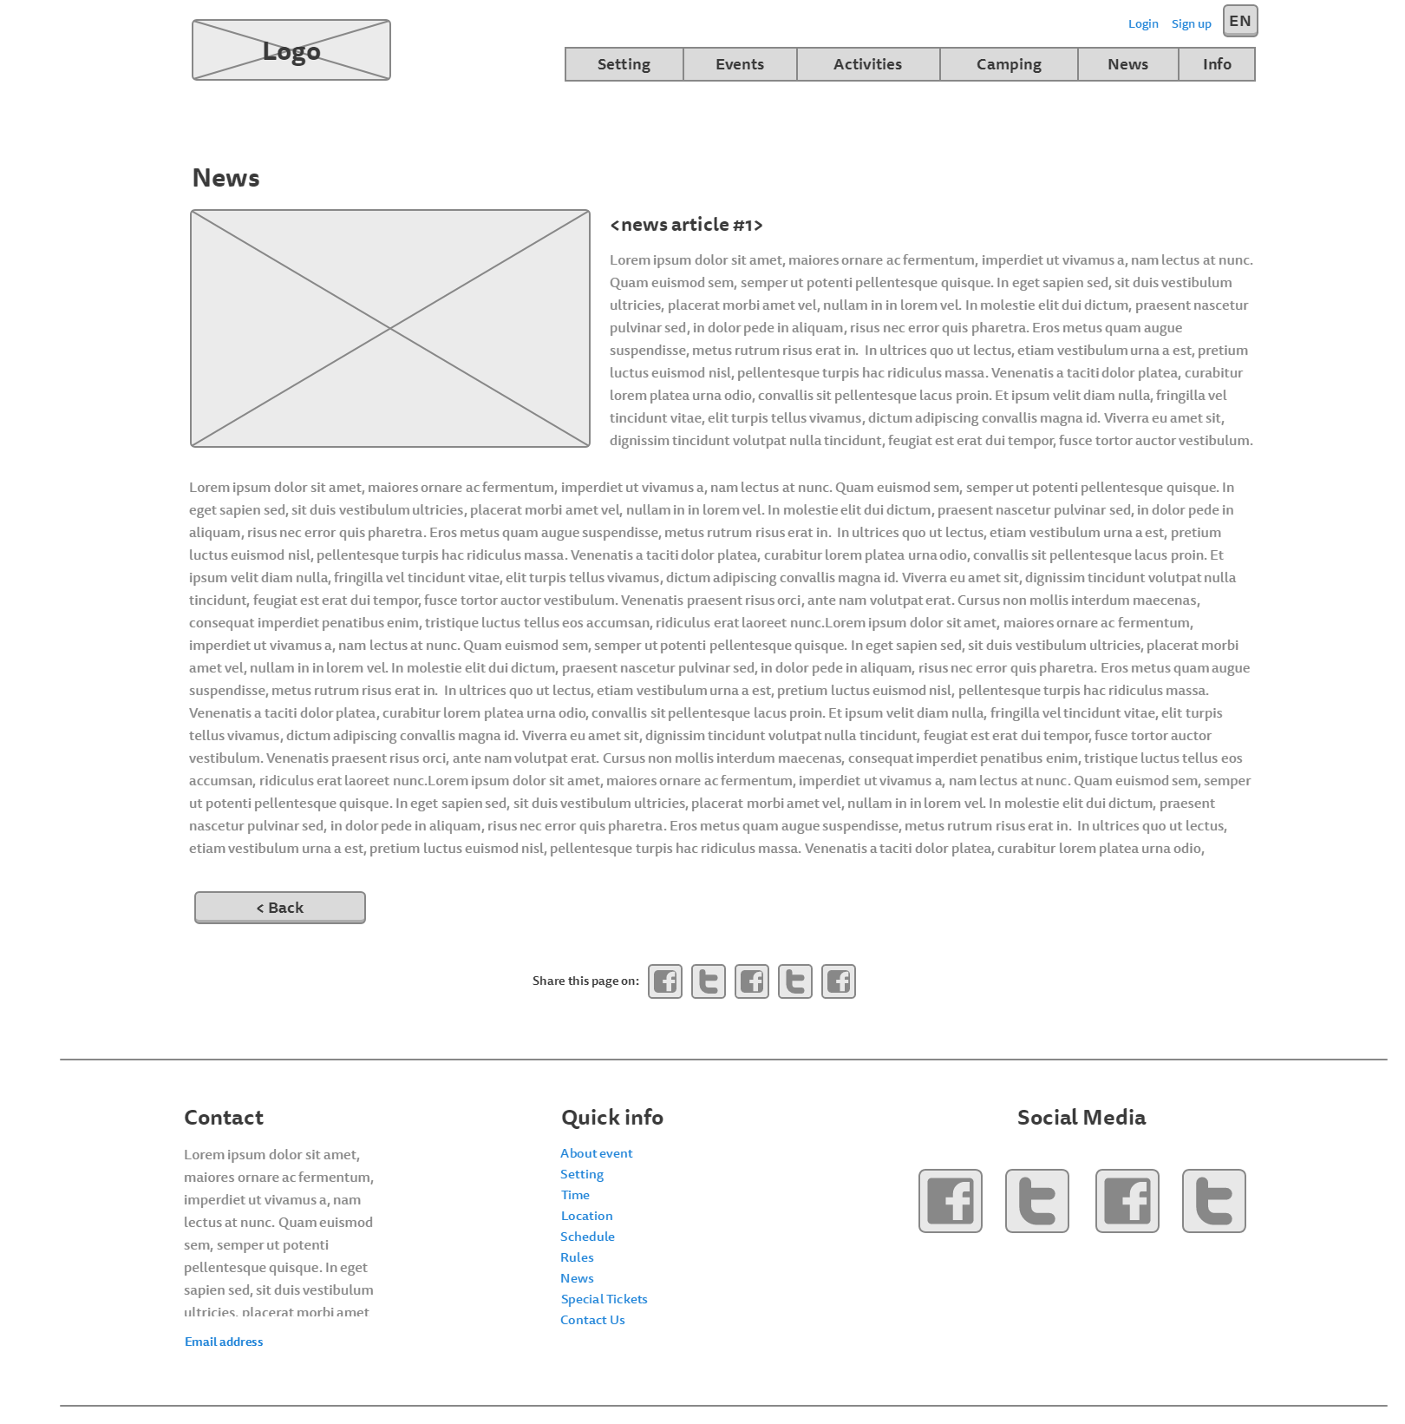

## About page:11-Info

## Login page:

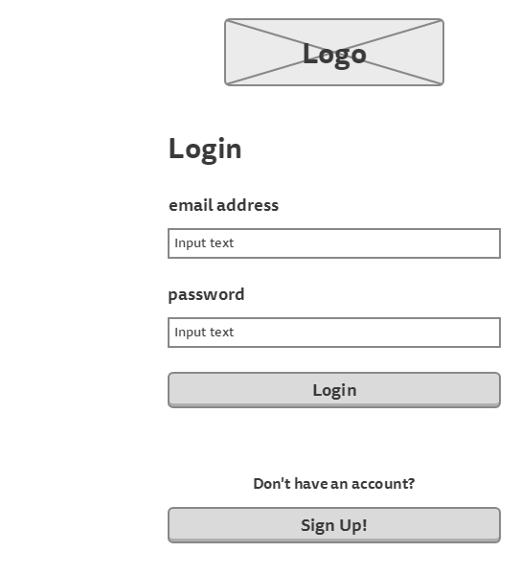

## Sign up page:

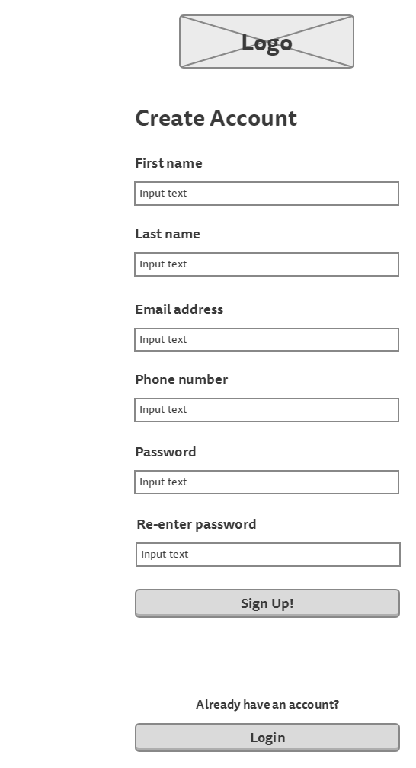

## Participant’s information page

(to show tickets information)

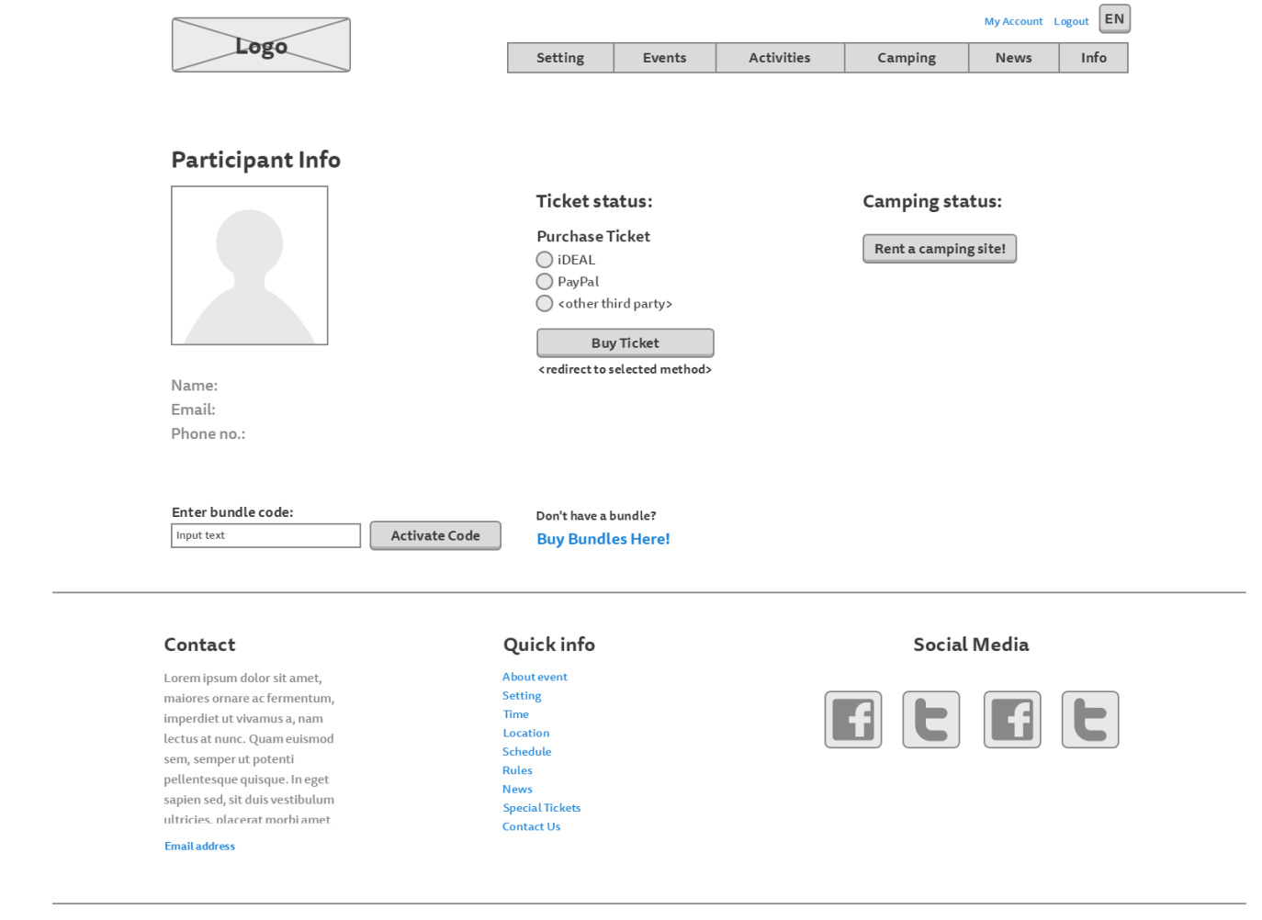

## Participant’s information page

(to show camping information)

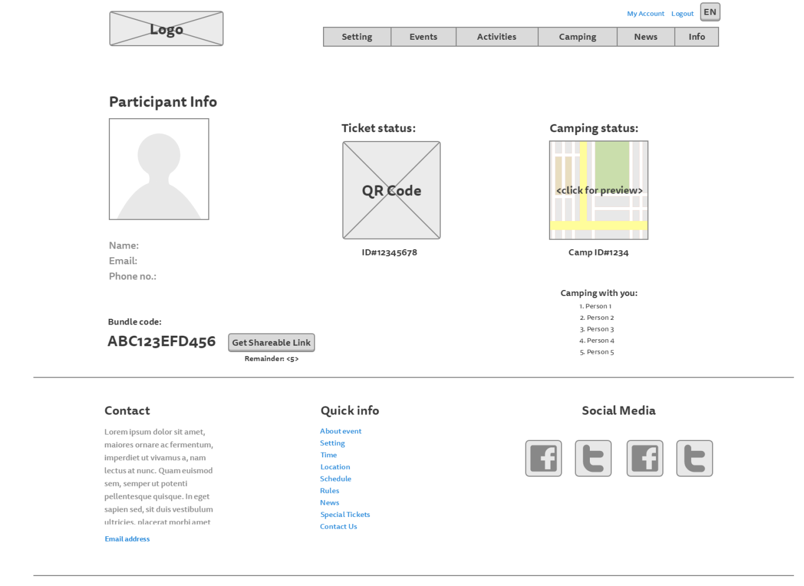

## Camping registration page:

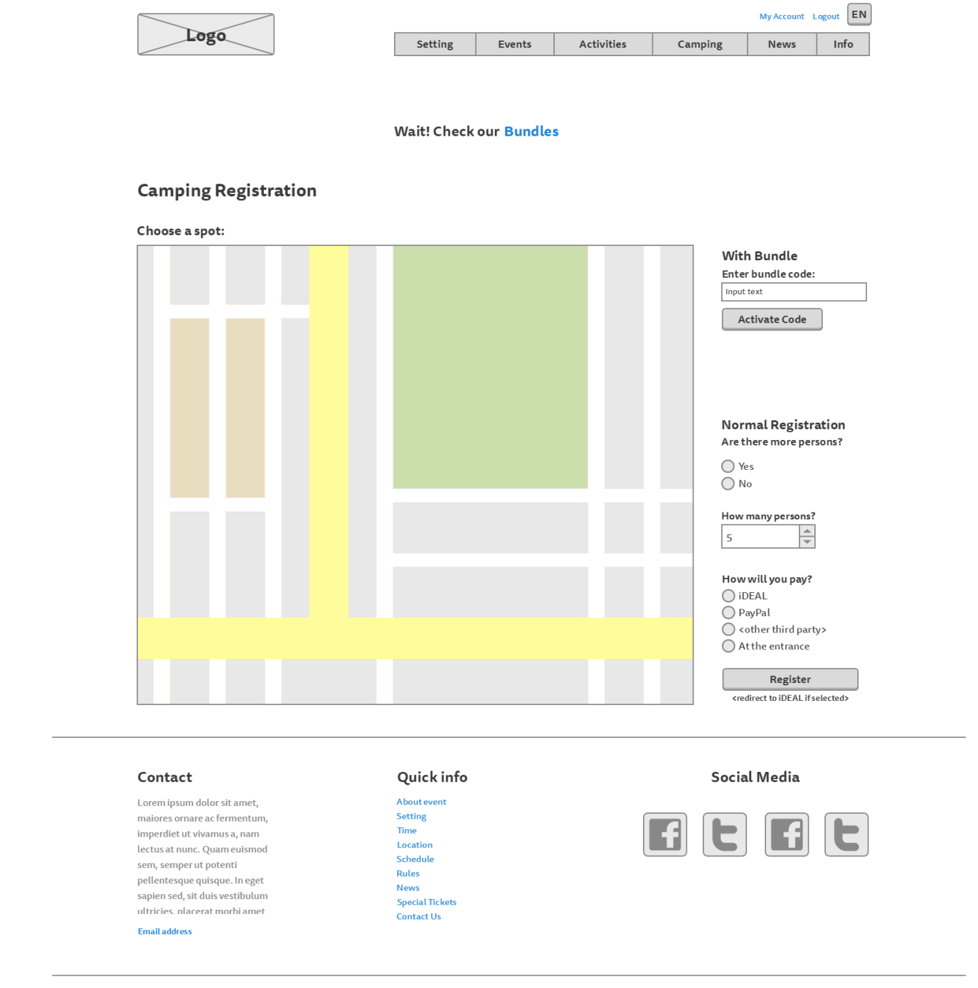

## Bundles page:

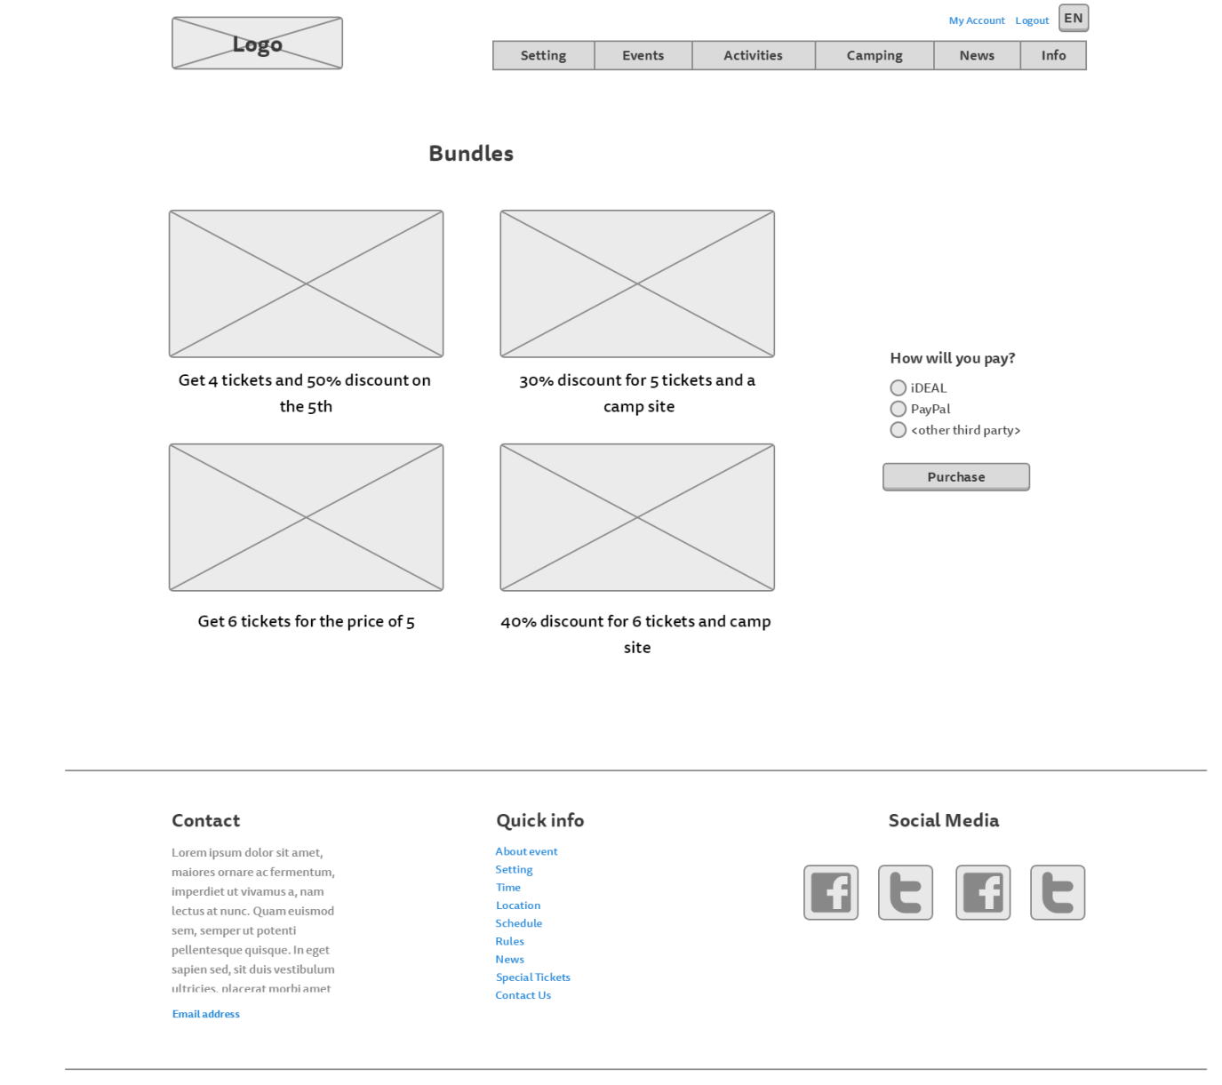

# Visual Design

## Homepage:

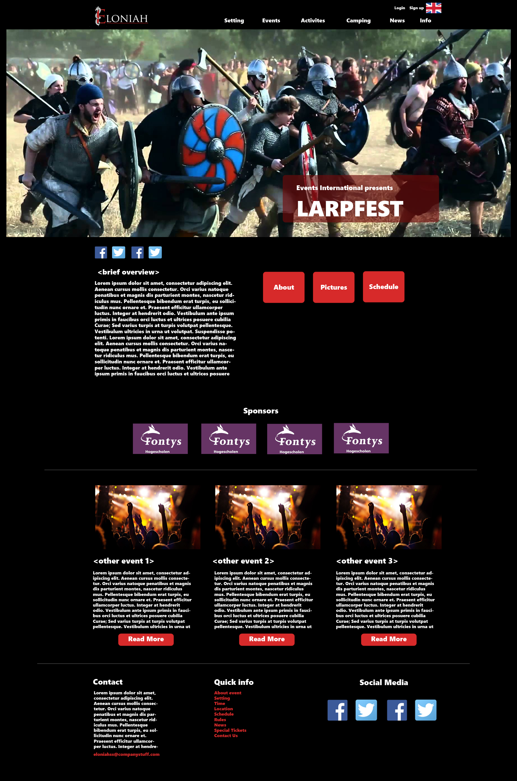

## Story So Far:

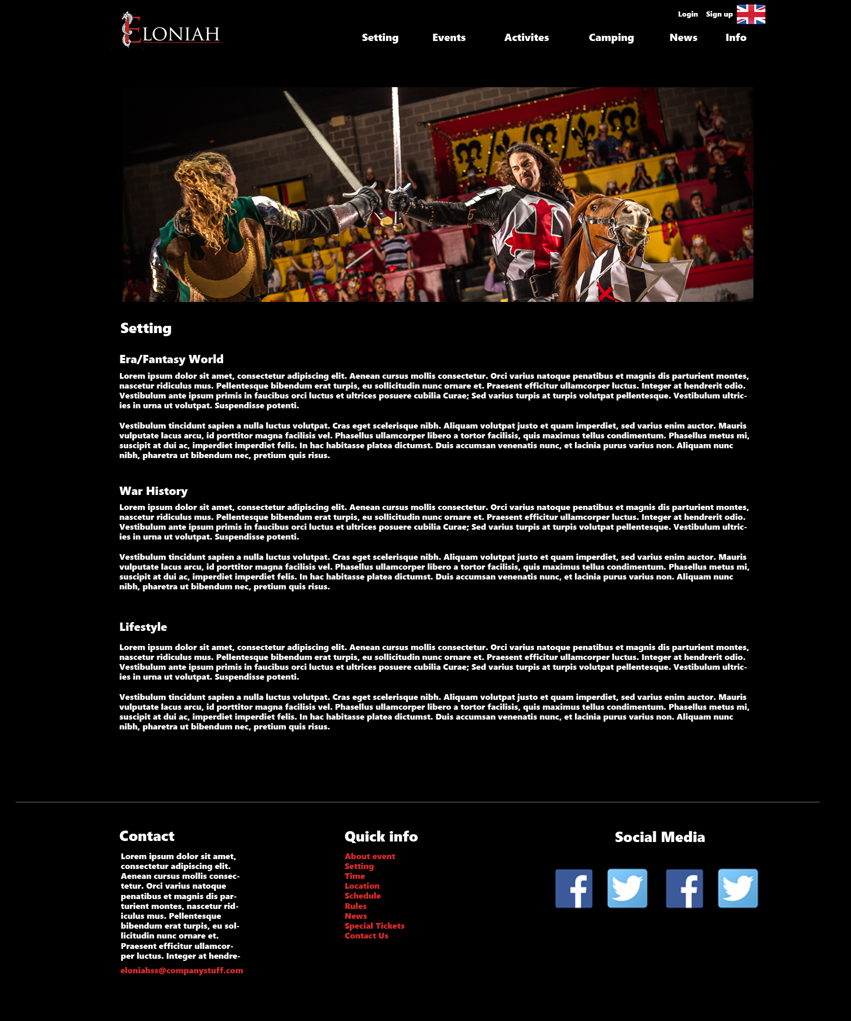

## Rules page:

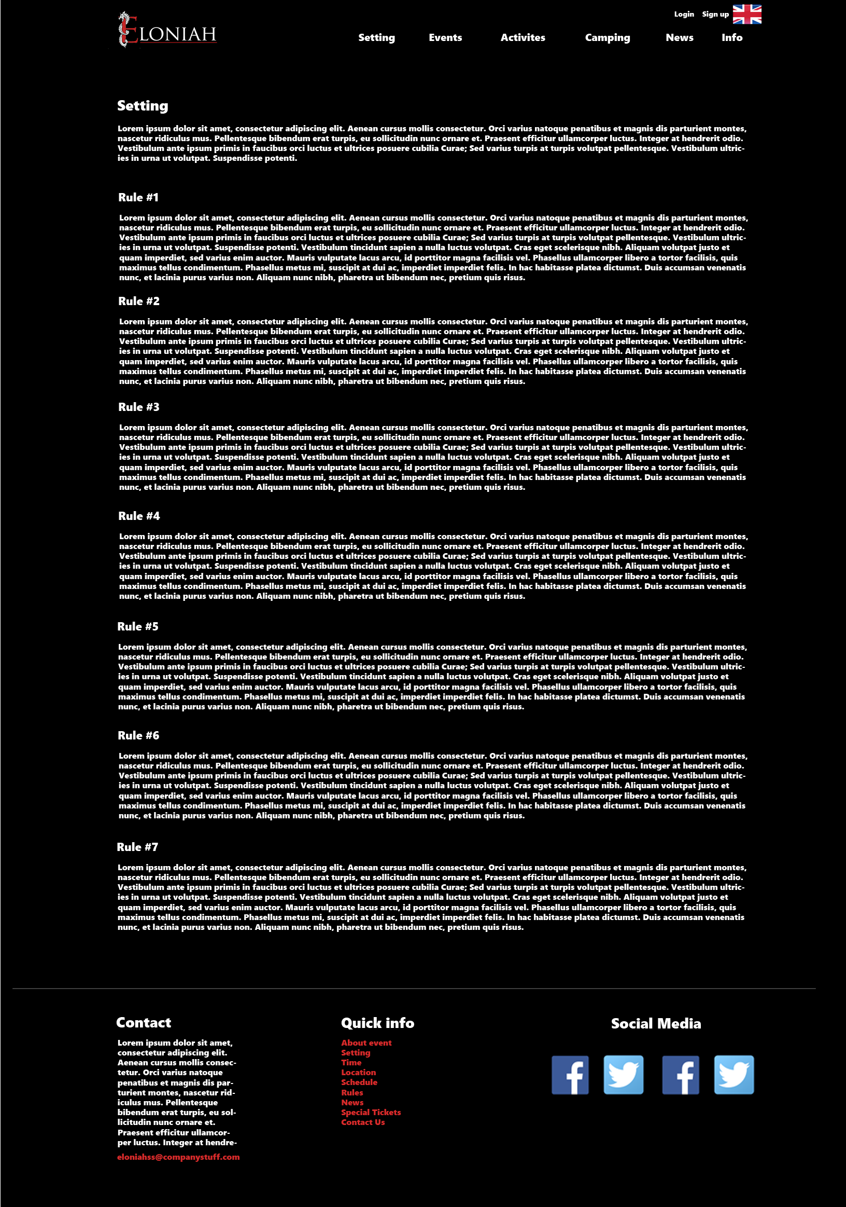

## Events page

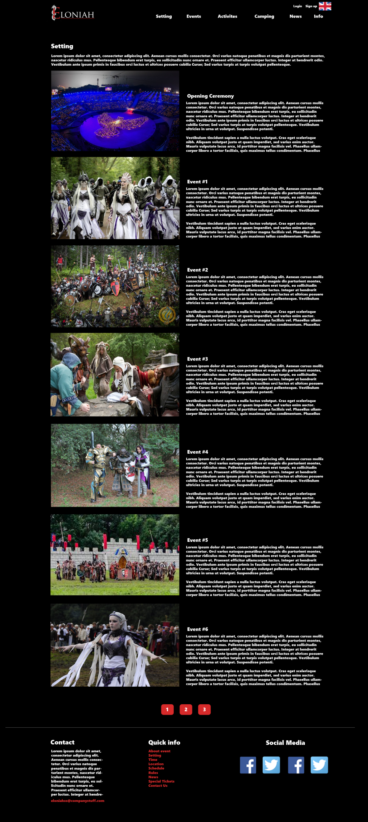

## Activities page:

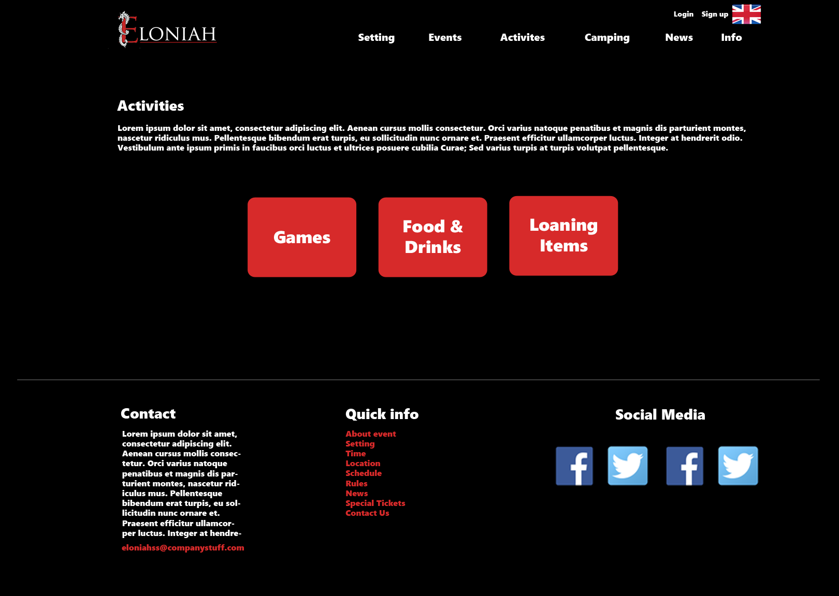

## Food, drinks and loaning items page

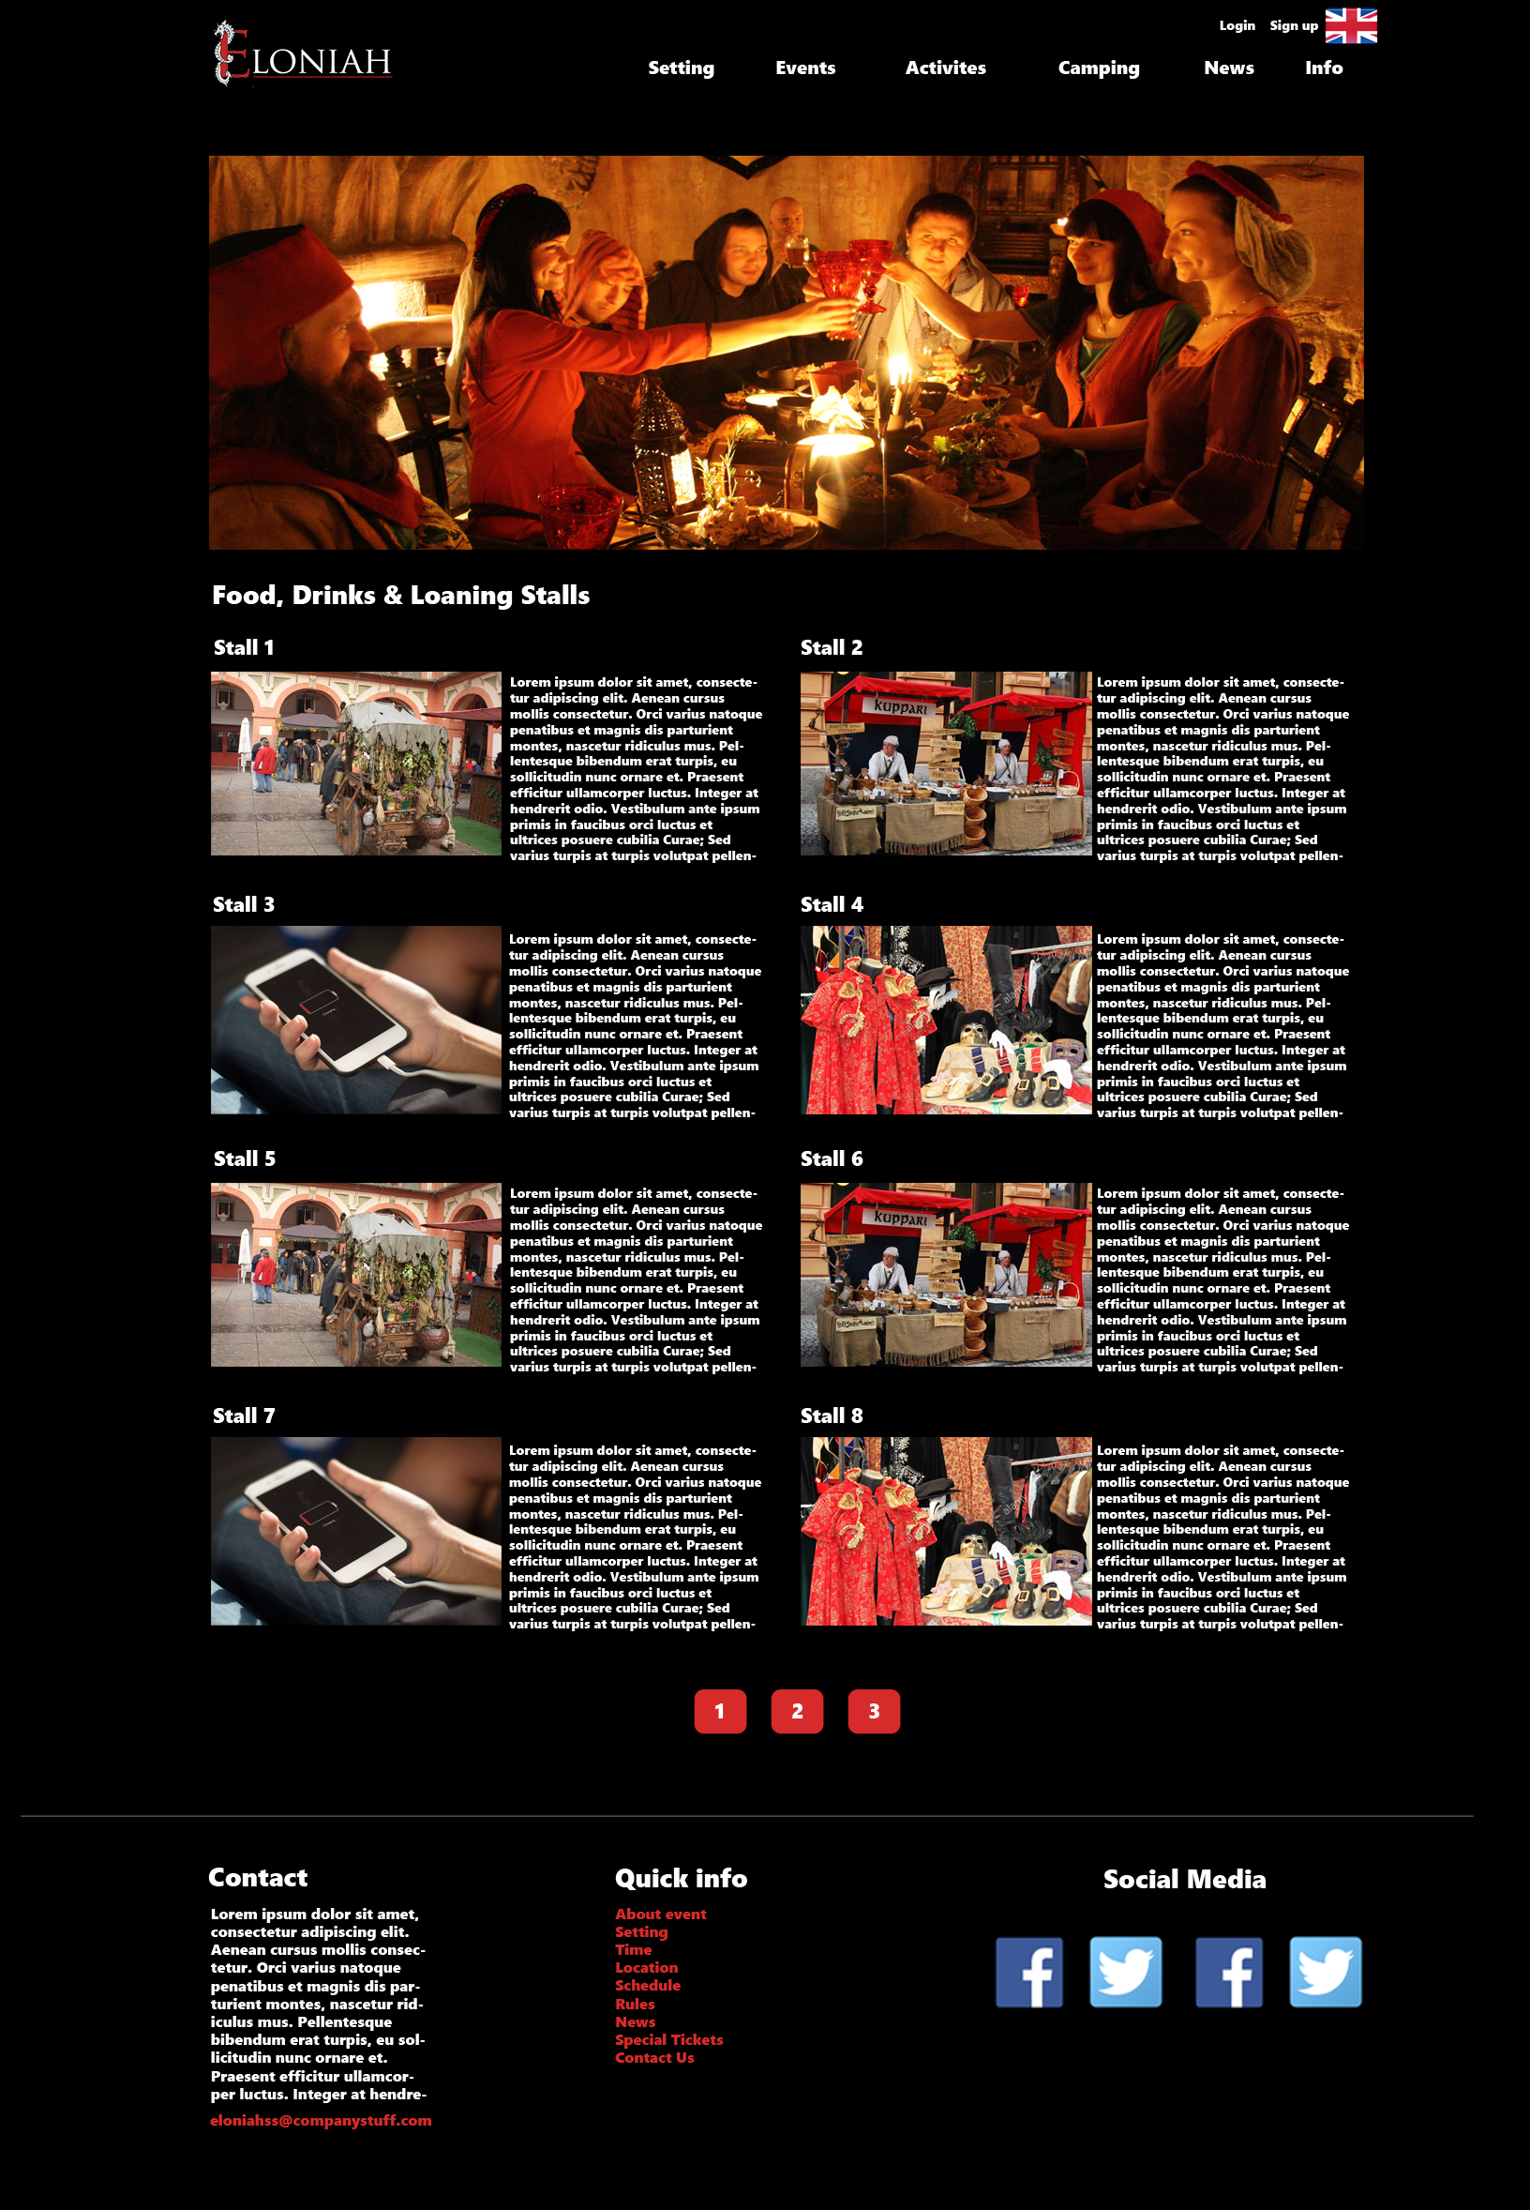

## Games page:

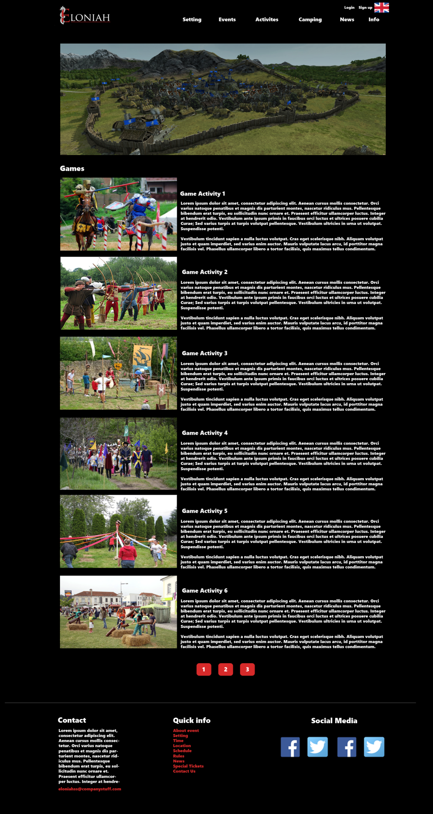

## Camping page:

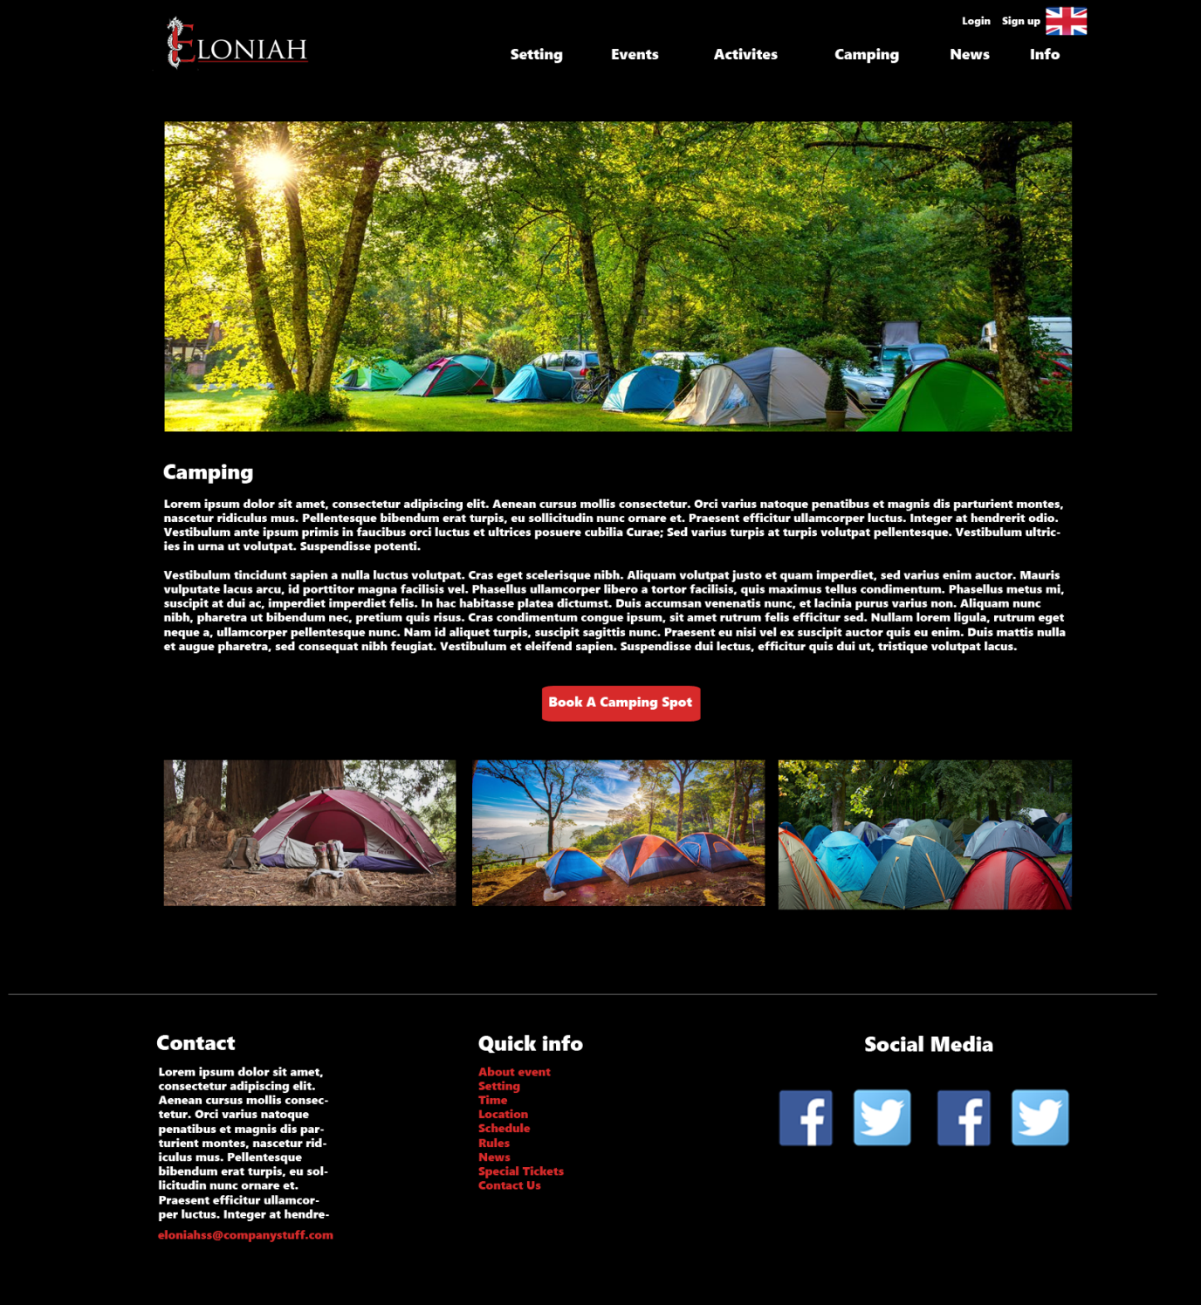

## News page:

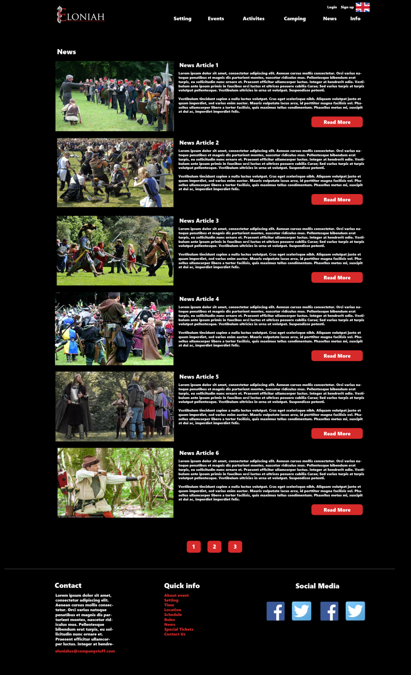

## News – read more:

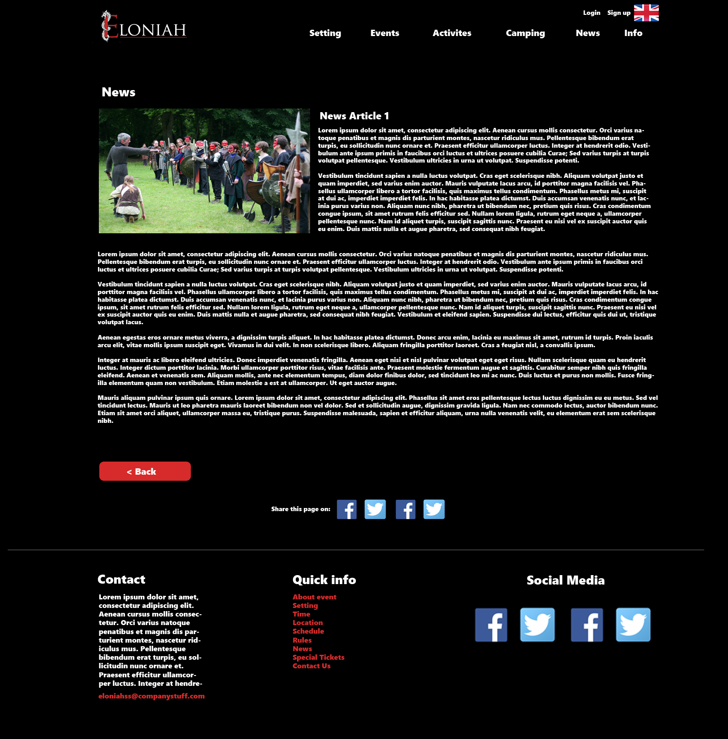

## About page:C:\Users\yenth\AppData\Local\Microsoft\Windows\INetCache\Content.Word\11-Info.png

## Login page:

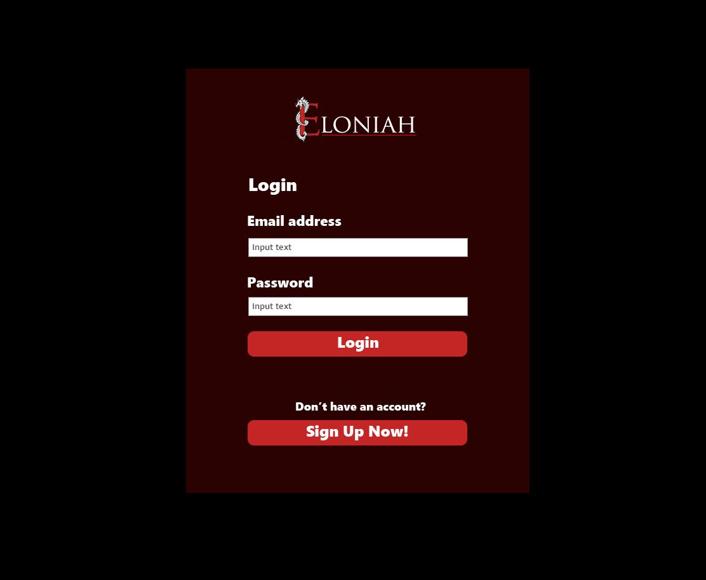

## Sign up page:

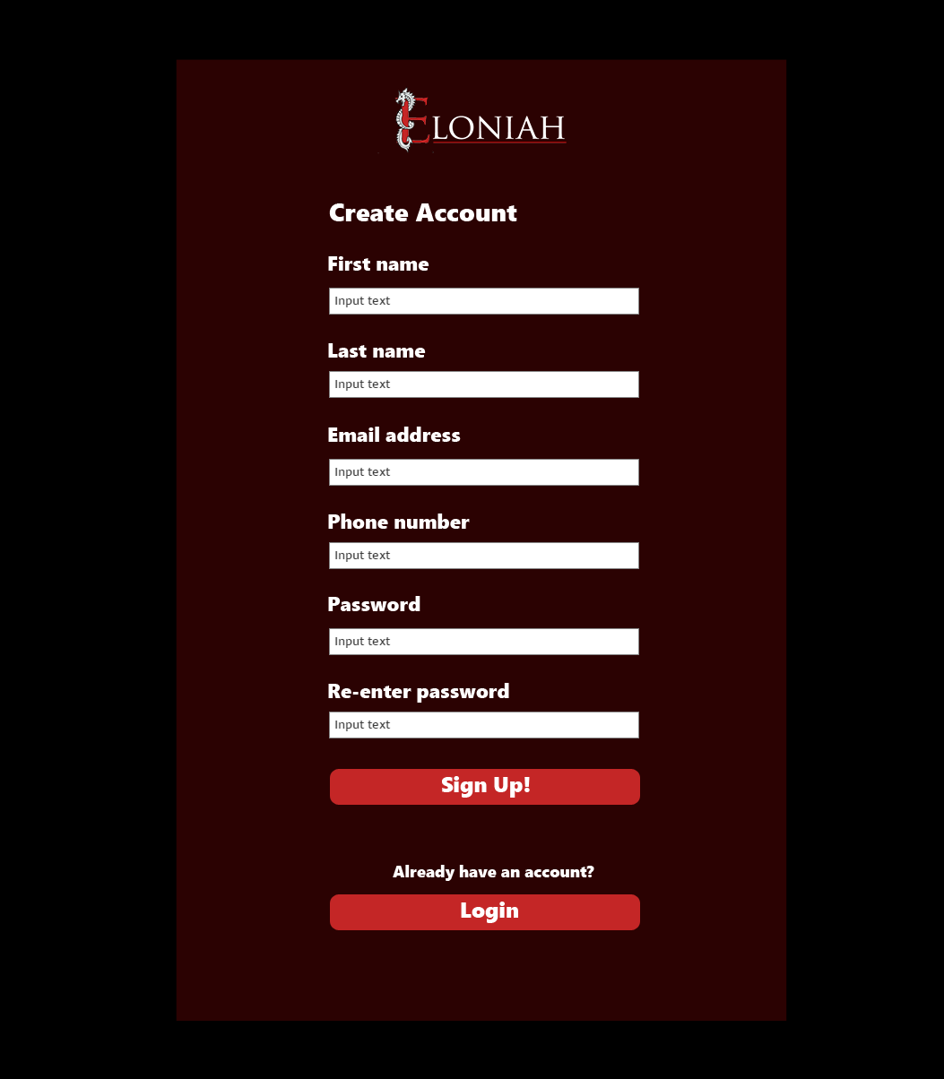

## Participant’s information page

(to show tickets information)

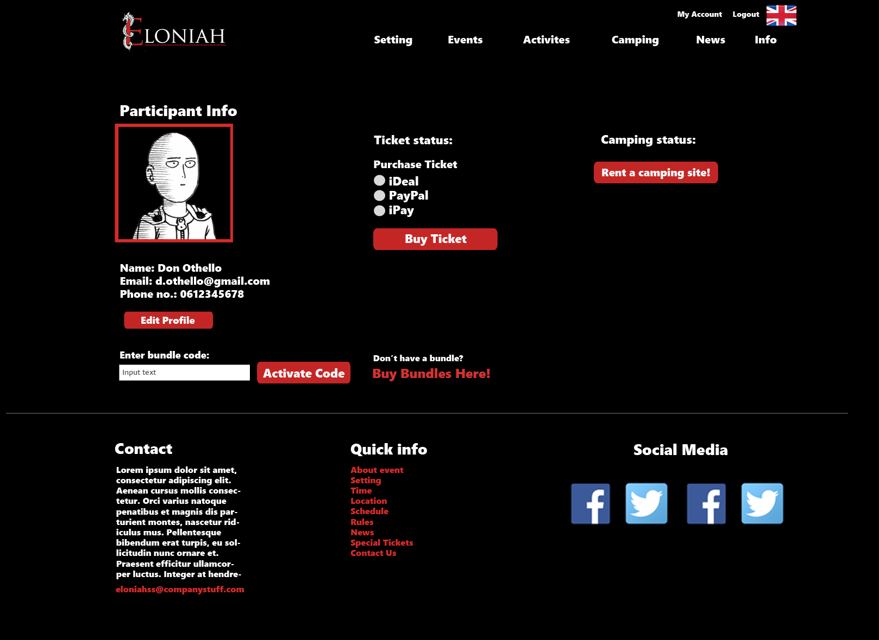

## Participant’s information page

(to show camping information)

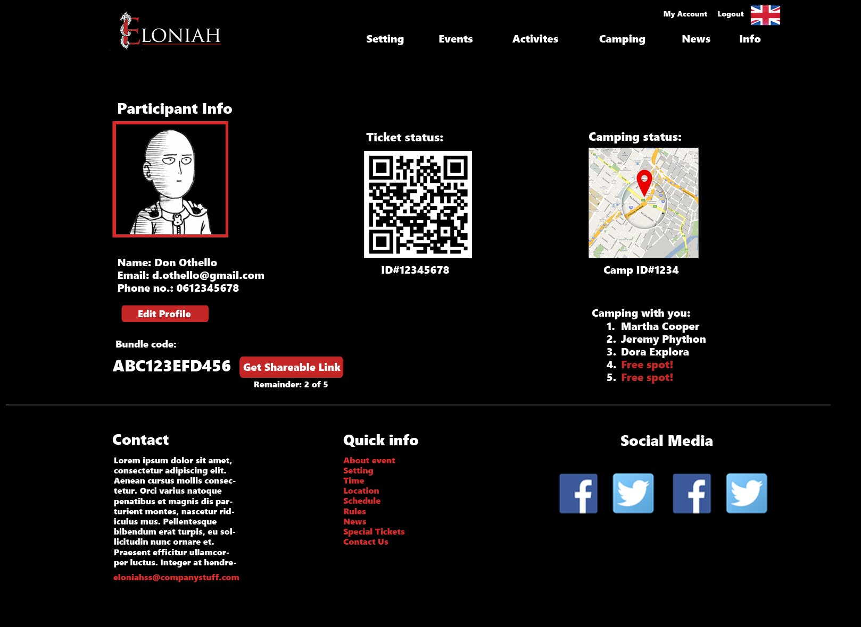

## Camping registration page:

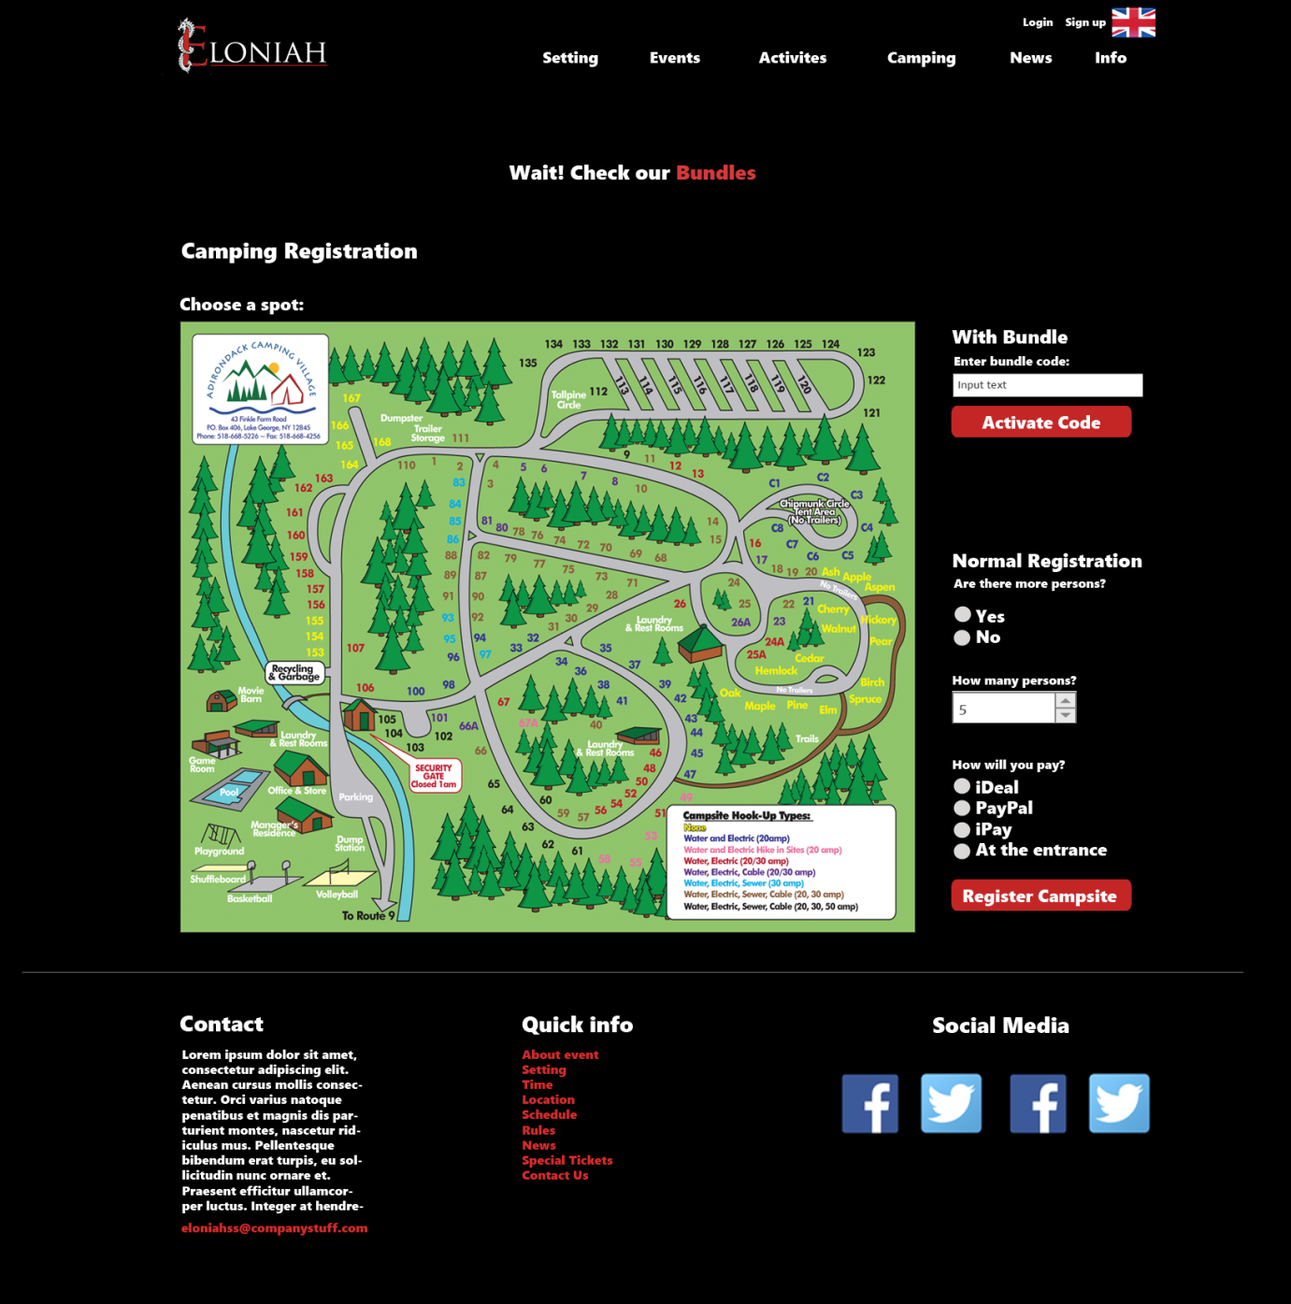

## Bundles page:

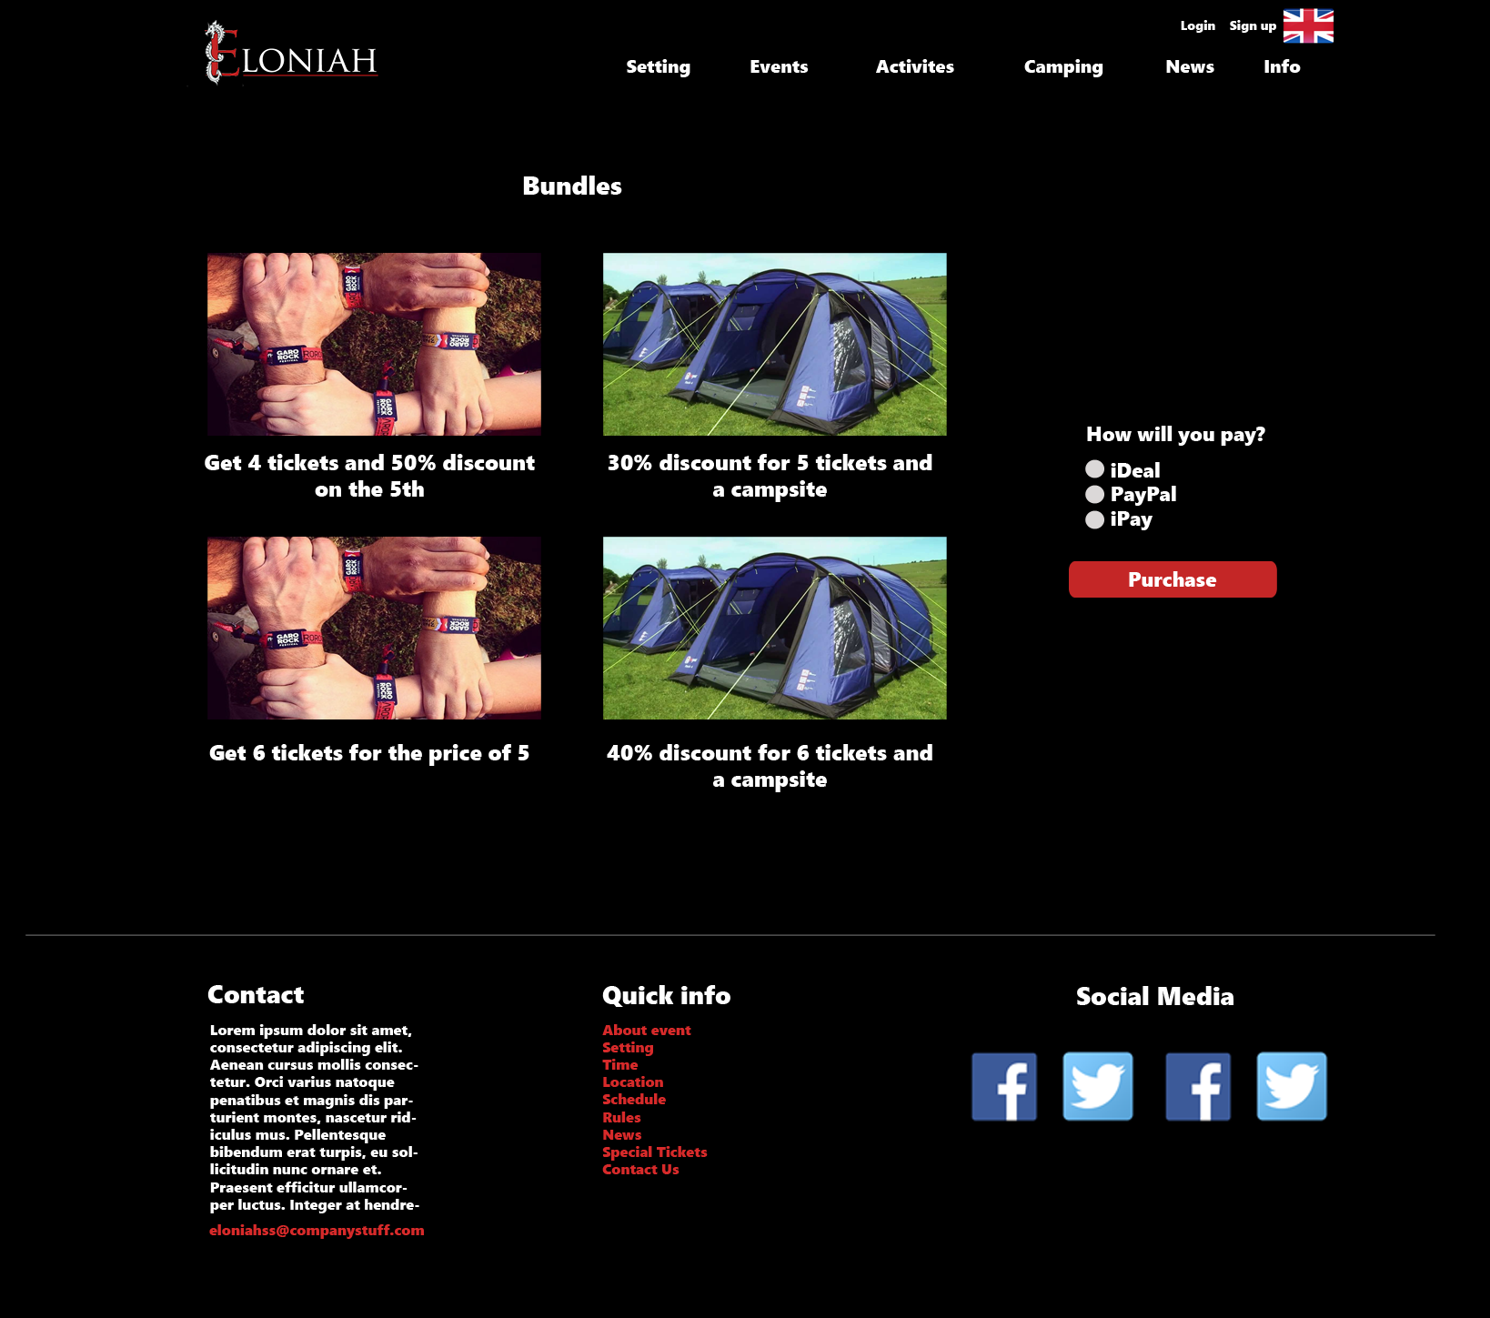

# ERD

* **Red**: The core entities.
* 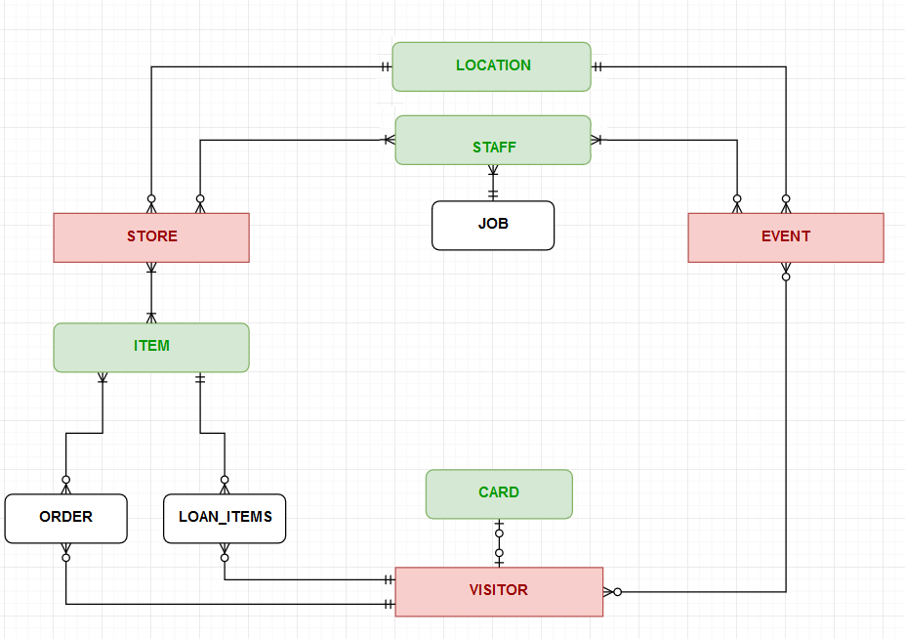**Green**: The entities supporting the core ones.
* **Black**: The entities supporting implementation.